Three distinct patterns of mental health response following accidents in mountain sports – a follow-up study of individuals treated at a tertiary trauma center

Hanna Salvotti, MD1,2, Piotr Tymoszuk, PhD3, Mathias Ströhle, MD4, 5, Peter Paal, MD5,6,7,8, Hermann Brugger, MD8,9,10, Martin Faulhaber, PhD5,11, Nicola Kruijer, MD12, Barbara Sperner-Unterweger, MD1, and Katharina Hüfner, MD1,5 ✉

1 Department of Psychiatry, Psychotherapy, Psychosomatics and Medical Psychology, University Hospital for Psychiatry II, Medical University of Innsbruck, Innsbruck, Austria.  
2 Department of Neurosurgery, University Hospital of Regensburg, Regensburg, Germany  
3 Data Analysis as a Service Tirol, Innsbruck, Austria  
4 Department of Anesthesiology and Critical Care Medicine, Bezirkskrankenhaus Kufstein, Kufstein, Austria.  
5 Austrian Society of Mountain and High-Altitude Medicine, Mieming, Austria

6 Department of Anesthesiology and Intensive Care Medicine, Paracelsus Medical University, Salzburg, Austria.  
7 Austrian Board of Mountain Safety (Österreichisches Kuratorium fur Alpine Sicherheit), Innsbruck, Austria.  
8 International Commission for Mountain Emergency Medicine (ICAR), Kloten, Switzerland.  
9 EURAC Research, Institute for Mountain Emergency Medicine, Bolzano/Bozen, Italy.  
10 International Society of Mountain Medicine (ISMM).  
11 Department of Sport Science, University of Innsbruck, Innsbruck, Austria.  
12 Department of Orthopedics and Traumatology, Medical University of Innsbruck, Innsbruck, Austria.

✉ Correspondence: [Katharina Hüfner, MD <katharina.huefner@tirol-kliniken.at>](mailto:katharina.huefner@tirol-kliniken.at)

# Abstract

**Background:** The restorative effect of physical activity in natural alpine environments on mental and physical health is increasingly recognized. However, mountain sports are also linked to a risk of accidents. We aimed to characterize mental health in individuals following mountain sport accidents requiring professional medical management.

**Methods:** 307 adult victims of mountain sport accidents treated at the hospital of the Medical University of Innsbruck (Austria) between 2008 and 2020 competed the cross-sectional survey study at a median 44 months following the admission. Symptoms of post-traumatic stress disorder (PTSD, PCL-5), anxiety, depression, and somatization (PHQ), resilience (RS-13), sense of coherence (SOC-9L), post-traumatic growth (PTGI) and quality of life (EUROHIS-QOL), as well as sociodemographic and clinical information were obtained from an online survey and extracted from electronic health records. Mental health outcome patterns were investigated by semi-supervised medoid clustering and modeled by machine learning.

**Results:** 19% of participants scored positive for at least one PTSD diagnostic domain. Three comparably sized subsets of individuals were identified: a (1) neutral, (2) post-traumatic growth and (3) post-traumatic stress cluster. The post-traumatic stress cluster was characterized by high prevalence of symptoms of mental disorder, low resilience, low sense of coherence and low quality of life as well as by younger age, the highest frequency of pre-existing mental disorders and persisting physical health consequences of the accident. Individuals in this cluster self-reported a need for psychological support following the accident and more cautious behavior during mountain sports since the accident. Reliability of machine learning-based prediction of the cluster assignment based on 40 variables available during acute medical treatment of accident victims was limited.

**Conclusion:** A subset of individuals develop symptoms of mental health disorders including symptoms of PTSD when assessed at least 6 months following the mountain sport accident. Since early identification of these vulnerable patients remains challenging, psychoeducational measures for all patients and low-threshold access to psychological support is key for a successful interdisciplinary management of individuals following mountain sport accidents.

Word count abstract: 297

# Keywords

mountain sport accident, machine learning, mental health, post-traumatic growth, post-traumatic stress disorder

# Introduction

Physical activity in mountains, such as hiking, climbing, alpine skiing or ski touring, are gaining increasing popularity, a trend that has been accelerated by the COVID-19 pandemic (1). Outdoor physical activity in general and mountain sports in particular exert beneficial effects on physical and mental health (2–4). However, mountain sports are also associated with the risk of accidents and injury (5,6), which could subsequently lead to development of post-traumatic stress disorder (PTSD) or symptoms of other stress-related mental disorders.

Diagnostic symptoms of PTSD include the domains of re-experiencing (criterion B), avoidance (criterion C), negative alterations in cognition and mood (criterion D) and hyper-arousal (criterion E) (7–9), which can occur following self-experiencing or witnessing of a traumatic event such as actual or threatened death, injury, physical or sexual violence. PTSD may co-occur with symptoms of depression and anxiety and substance abuse disorders (10,11). Although most individuals have experienced at least one traumatic event during their lifetime (12,13), the prevalence of PTSD in the general European population has been estimated between 0.38 to 6.67% (14,15). Yet, up to 26% of acute physical trauma patients have been reported to develop PTSD (16).

So far it has proven difficult to reliably identify early predictors of subsequent PTSD development following accidents. While some recent studies on specific populations have identified risk factors, such as pre-existing psychological distress (17) or symptoms of mental disorders (18), others have focused on the arousal and stress reaction during acute trauma and peri-traumatic period as candidate predictors (19). These results require validation and further generalization before they can be implemented into routine care (20,21). ~~Many trauma patients at risk of PTSD undergo intensive acute medical care in emergency departments, which poses a challenge for implementation of early diagnostic and psychological preventive measures (22). Furthermore, efficacy of such acute psychological interventions at preventing PTSD in trauma patients is uncertain, probably due to large heterogeneity of study cohorts (23).~~

Resilience, i.e. the ability to bounce back from adversities can protect an individual from developing PTSD and can help to explain why most people do not develop PTSD despite the high prevalence of traumatic events in the general population (25,26). Generally individuals who perform mountain sports display high resilience values (2). Post-traumatic growth can occur in individuals struggling to overcome the consequences of a traumatic event and describes a psychological adjustment reaction which can lead to a new appreciation of life with strengthened perceptions of self, others, and meaning of the event (24). Although both are salutogenetic concepts their exact link is still under investigation

When considering the large number of individuals engaging in mountain sports today, it is essential to characterize the mental health consequences of accidents during mountain sports. Counteracting the development of PTSD or other mental health problems following an accident in mountain sports is essential to preserve the positive mental health effects of physical activity in an alpine environment despite the associated risk of accidents. The available data on the consequences of accidents during mountain sports on subsequent mental health are scare. Prior studies were performed on mountain guides, rescuers or avalanche accident survivors and mostly did not include clinical data (27–31).

We analyzed mental health readouts such as symptoms of PTSD, anxiety, depression, and somatization, resilience, sense of coherence, post-traumatic growth and quality of life in 307 individuals treated at the Hospital of the Medical University of Innsbruck, Austria following a mountain sport accident by means of semi-supervised clustering. Additionally, we searched for early sociodemographic and clinical predictors of subsequent mental health impairment following a mountain sport accident with a machine learning approach.

# Methods

## Ethics

The study was conducted in accordance with the Declaration of Helsinki and European data policies. All participants gave electronically signed written informed consent to participate. Participants’ data were processed in anonymized form. The study protocol was approved by the ethics committee of the Medical University of Innsbruck (approval number: 1472/2020).

## Participants

Individuals treated following a mountain sport accident at the Department for Orthopedics and Traumatology at the Hospital of the Medical University of Innsbruck between 1st January 2018 and 31st December 2020 (i.e., at least 6 months prior to the start of the study) were screened for participation. Individuals fulfilling the inclusion criteria: age 18 years, residence in a German-speaking country and proficiency in German (n = 4559) were invited to participate in the online study survey via conventional mail. Out of the invited subjects, 387 completed the survey. The study results of 307 individuals with complete psychometric data were analyzed (overall analysis inclusion rate: 6.7%, **Figure 1**, **Supplementary Tables S1** - **S3**).

## Procedures

Details on study procedures and variables are provided in **Supplementary Methods** and **Supplementary Table S1**.

Sociodemographic (e.g. age, sex, education, profession, income, prior mountain sport accidents and prior traumatic events), accident- and recovery-related (e.g. mode of rescue, psychological support, persistent physical health consequences) and psychometric variables were recorded with a cross-sectional online survey.

The psychometric battery consisted of German versions of assessment tools for symptoms of post-traumatic stress disorder (PCL-5 DSM-5: PTSD checklist for DSM-5) (39), anxiety (GAD-7: 7-item general anxiety disorder scale) (32), depression (PHQ-9 patient health questionnaire 9 item scale for depressive symptoms)(33,34), panic (PHQ-panic module) (33,34), somatization (PHQ-15: patient health questionnaire 15 item scale assessing common somatic symptoms as a substitute for somatization) (35), resilience (RS13: 13-item resilience scale) (36), sense of coherence (SOC-9L: Leipzig 9-item sense of coherence questionnaire) (37), quality of life (EUROHIS-QOL 8: 8-item EUROHIS project quality of life scale) (38), post-traumatic growth (PTGI: post-traumatic growth inventory) (24) and The tools displayed good-to-excellent consistency (40) (McDonald’s > 0.8, **Supplementary Table S2** and **S3**).

Clinically significant symptoms of anxiety (GAD-7 10), depression (PHQ-9 11) (41), somatization (PHQ-15 11) (35) and resilience classes (low: RS-13 0 - 65, moderate: 66 - 72, high: 73) (36) were defined with published cutoffs.

Separate scores were calculated for domains B, C, D and E of the PCL-5 tool along with the total score being the sum of all items. Each PCL-5 item was scored as 0: not at all, 1: a little bit, 2: moderate, 3: quite a bit and 4: extremely. Participants positive for the B domain or C domain PTSD symptoms were identified by at least one item per domain scored with ‘moderate’ or higher. Participants positive for the D or E domain PTSD symptoms were identified by at least two items per domain scored with ‘moderate’ or higher. Significant PTSD symptoms were assumed in participants screened positive for at least one of the B, C, D or E PCL-5 domains (39).

Traumatic events prior to the accident were assessed with the DIA-X tool (42). Flashback frequency was surveyed as none, > 1/year and > 1/month. Smoking was surveyed as a single yes/no question. Problematic alcohol use was investigated with the CAGE tool (43). Data on the type of the mountain sport during which the accident occured, injury diagnosis, severity (AIS: abbreviated injury scale) (44) and body location, hospitalization, surgery and number of surgical ICD-10 diagnoses were extracted from electronic patient records.

The training and test participant subsets (3:1 size ratio) were obtained by random splitting which minimized differences in in sociodemographic, medical history, clinical and accident- and injury-related variables assessed by Gower distance (**Figure 1**). The training subset size (n = 230) was sufficient for clustering analysis as assessed by Hopkins metrics of 0.74 indicative of substantial spontaneous clustering tendency (45).

## Analysis endpoints

The primary analysis endpoint was assessment of mental health in individuals following mountain sport accident by clustering using standardized psychometric tools for symptoms of PTSD, anxiety, depression, panic, somatization, , resilience, sense of coherence, post-traumatic growth and quality of life ~~PTSD~~. The secondary analysis endpoints were (1) to compare demographic, socioeconomic and clinical characteristics between the different mental health clusters of mountain accident victims and (2) to identify patients at risk of mental disorders based on a set of explanatory variables available during acute medical treatment of the individuals following mountain sport accidents.

## Statistical analysis

Details on statistical analysis are provided in **Supplementary Methods**

Statistical analysis was done with R version 4.2.3. Numeric variables are displayed as medians with interquartile ranges. Categorical variables are presented as percentages and counts. Differences in numeric variables were analyzed by Mann-Whitney or Kruskal-Wallis test with r or effect size statistics. Differences in categorical variable distribution were assessed by test with Cramer V effect size statistic (46).

The training subset was clustered in respect to normalized median-centered psychometric scores by partition around medoids with cosine distance (47,48). This algorithm had a good explanatory performance (ratio of between-cluster sum of squares to total sum of squares), separation between clusters (average silhouette width) (49) and the superior accuracy in 10-fold cross-validation (50) as compared with the hierarchical clustering and KMEANS algorithms. The k = 3 cluster number choice was based on the bend of within-cluster sum of squares curve and maximal mean silhouette statistic (45,49). The training subset observations were assigned to the clusters with an inverse distance-weighted 27-nearest neighbor classifier.

Multi-parameter machine learning classifiers of the mental health cluster assignment were trained with the canonical random forest algorithm (51,52), regularized neural network with a single hidden layer (53), support vector machine algorithm with radial kernel (54,55), recursive partitioning (56,57), multinomial elastic net regression (58,59), and conditional random forest algorithm (60–62). The cluster assignment was predicted for the test subset and the classifiers’ performance at predicting the cluster assignment was assessed by the accuracy and statistics, Brier score as well as sensitivity and specificity of predicted assignment to the post-traumatic stress cluster (63–65).

# Results

## Characteristic of the study cohort

307 individuals with complete psychometric data sets were analyzed. The median time between the trauma center admission following the accident and survey completion was 1343 days (interquartile range: 804 - 1441 days). As compared with the analyzed participants, patients who did not respond to the study invitation were characterized by a higher frequency of biking accidents, lower rate of alpine ski/snowboard accidents, less severe injury, lower hospitalization and surgery rates, and fewer number of surgical ICD-10 diagnoses per patient (**Supplementary Table S4**). The survey participants excluded from the analysis due to missingness of psychometric data had significantly lower income, less severe injuries, more frequent injuries of the upper limbs, less frequently required hospitalization or surgery, and suffered less frequently from persistent physical health consequences of the accident than the analyzed participants (**Supplementary Table S5**). Effect sizes of the differences between the included and excluded participants were weak (V 0.22 or r 0.15).

The analyzed participants were predominantly middle-aged (median: 51, interquartile range: 33 to 60 years) and 45% of them were females. The vast majority had secondary or tertiary education grade (83%) and were professionally active (68%). Less than 8% of participants worked in a search and rescue or mountain sport profession. Annual household incomes of 45000 Euro was reported by 42% of participants. Less than 10% of participants were smokers or at risk of problematic alcohol use. Pre-existing physical disorders were reported by 15% of participants with cardiovascular, neurological and metabolic illness being the most frequent. Mental disorders prior the accident affected 5.2% of the cohort with affective (2.3%) and somatoform disorders (1.6%) as the leading conditions. Four of ten participants had experienced or witnessed a traumatic event prior to the accident, 10.4% participants experienced two or more traumatic events.(**Table 1**).

Mountain sport accidents in the past were reported by 38% of participants. Most of the investigated accidents occurred during alpine skiing, snowboarding or cross-country skiing (64%) followed by biking (16%) and classical mountain sports such as climbing, hiking, mountaineering or back-country skiing (NA%). One-third of participants were alone during the accident (32%) and, in most cases, were the only person injured (77). Professional rescue service was involved in 29% of the accidents. In 35% of participants the injury was moderate ( 2) and in 28% severe-to-critical (AIS 3). Limb injuries were the most common followed by injuries of head and face (**Supplementary Figure S1A**). Hospitalization and surgery rates following the accident were 26% and 14%, respectively. Psychological or psychiatric support after the accident was provided to 9.1% individuals. A subset of participants (get_percent(ptsd$dataset, 'psych_support_need')$percent['yes']%), who had not received psychological or psychiatric support, declared a need following the accident. Despite persisting physical consequences of the accident, which affected 37% of participants and flashbacks during mountain sport at the time of the questionnaire completion in 40% of the cohort, most participants returned to the same mountain sport following the accident (85%). Yet, 65% described their behavior during mountain sport as more cautious (**Table 2**).

At least one diagnostic criterion of PTSD (defined by a positive scoring in domains B,C,D,E, of the PCL-5 tool) was met by 19% of participants. The domain B PTSD symptoms were the most common (11%) and the domain D symptoms were the least frequent (5.2%). Solely four patients (1.3%) were screened positive for all four diagnostic criteria of PTSD (**Table 3**, **Supplementary Figure S1BC**). Clinically relevant symptoms of anxiety (2.3%), depression (5.5%) and somatization (4.9%) were rare in this cohort consisting of 68% highly resilient individuals (**Table 3**).

For clustering and modeling, the cohort was split into the training (n = 230) and test subset (n = 77). Significant differences of weak effect size between these subsets concerned resilience class distribution and scores of quality of life (**Supplementary Table S6**).

## Three clusters of mental health response following mountain sport accidents

To explore symptoms of PTSD and further facets of mental health following mountain sport accidents, we subjected the participants to partition around medoids clustering in respect to a broad range of psychometric scores (47,48) (**Supplementary Table S2**). Three mental health clusters were identified in the training subset: ‘neutral’, ‘PTG’ (post-traumatic growth) and ‘PTS’ (post-traumatic stress) and named after their key mental health characteristic (**Supplementary Figure S3**). Subsequently, the mental health cluster assignment could be validated in the test subset as evident from comparable fractions of explained clustering variance (training: 0.55, test: 0.52), comparable average silhouette statistics (training: 0.3, test: 0.26) (49), comparable cluster sizes, good visual cluster separation and high similarity between the corresponding clusters in the training and test cohort subsets (**Supplementary Figures S4 - S6**).

The mental health clusters were of approximately equal size. The neutral cluster was characterized by low scores of post-traumatic stress, anxiety, depression, panic, somatization, and post-traumatic growth along with high ratings of sense of coherence, resilience and quality of life. The PTG cluster demonstrated similarly low scores of major mental health disorders, high resilience and sense of coherence. Its key characteristic were the highest levels of post-traumatic growth. The remaining PTS cluster displayed the highest scores for post-traumatic stress, anxiety, depression, panic, somatization as well as poor sense of coherence, and low resilience and low quality of life. Post-traumatic growth scores in the PTS cluster were higher than in neutral but lower than in PTG cluster participants (**Figure 2**, **Supplementary Table S7**). Consequently, clinically relevant symptoms of anxiety (PTS: 6.4%), depression (PTS: 14%) and somatization (PTS: 10%) were present virtually only in the PTS cluster. Furthermore, frequencies of low (PTS: 42%) and moderate resilience classes (PTS: 28%) peaked in the PTS cluster. Finally, the frequency of flashbacks, PTSD symptoms specified by the B, C, D and E PCL-5 domains and the frequency of individuals scoring positive for at least one diagnostic domain of the PCL-5 (PTS: 35%) were the highest in PTS cluster (**Figure 3**, **Supplementary Table S7**).

## Distribution of demographic, socioeconomic and clinical characteristics between the mental health clustersi

Among 48 investigated demographic, socioeconomic, clinical, accident- and recovery-related variables, only 6 features (age, pre-existing physical illness, pre-existing mental disorder, need for psychological or psychiatric support following the accident, persistent physical health consequences of the accident, and caution during mountain sport following the accident) were found to differ significantly between the mental health clusters. The effect size of these differences was weak (**Supplementary Table S8**).

In more detail, individuals in the PTS cluster were the youngest of all participants and had the highest frequency of pre-existing mental disorders. The neutral cluster was in turn substantially enriched in males, and tertiary education and high-income individuals; these effects were, however, not significant. Participants suffering from pre-existing physical illnesses were significantly enriched in the PTG and PTS clusters. A similar, yet not significant tendency was observed for the frequency of prior traumatic events, which was higher in the PTG and PTS clusters as compared with neutral cluster individuals. There were no substantial differences in frequency of participants with a profession in the search and rescue field and employment structure between the clusters (**Figure 4**, **Supplementary Figure S7**). Participants reporting being alone during the accident, being the only culprit in the accident, and requiring companion or professional rescue were enriched in the PTG cluster. In turn, frequency of self-rescuers tended to be the highest in the neutral cluster. These differences in accident and rescue circumstances were not significant. We could not observe any substantial differences in accident season, mountain sport type, and numbers of injured persons between the clusters (**Figure 5A**, **Supplementary Figure S7**). There were no significant differences in severity and injury and its location between the clusters. However, moderate-to-severe injuries (AIS 2), hospitalization and surgery rates were higher in the PTG and PTS clusters as compared with neutral cluster patients (**Figure 5**).

There were no significant differences in rates of individuals who received psychological or psychiatric support after the accident between the clusters. Among PTG and PTS cluster individuals, 8.5% and 14%, respectively, reported need for psychological or psychiatric support following the accident as compared with none in the neutral cluster. Frequency of participants suffering from persistent physical health consequences of the accident was the highest in the PTS cluster (PTS: 52%, PTG: 32%, neutral: 27%). Analogically, PTS cluster patients reported the highest rates of cautious behavior during mountain sport following the accident (PTS: 78%, PTG: 67%, neutral: 49%). By contrast, percentages of participants who returned to the same mountain sport after the accident were comparable between the mental health clusters (**Figure 6**).

## Prediction of the mental health cluster assignment by demographic, socioeconomic and accident-related factors

Finally, we intended to model the mental health cluster assignment with demographic, socioeconomic, clinical and accident-related factors available during acute medical management of the patient (**Supplementary Table S9**) with seven popular machine learning algorithms: the random forests (51,52), neural networks (53), support vector machines (55), recursive partitioning (56), discriminant analysis (66,67), elastic net regression (58,59), and conditional random forests (60–62) (**Supplementary Table S10**). Such models would enable early identification of mountain sport accident victims at risk of mental health problems.

The cluster assignment models employing early predictors demonstrated a moderate-to-excellent prediction performance in the training subset of the study cohort (64% - 100% of correctly assigned observations, Cohen’s : 0.45 - 1, Brier score: 0.018 - 0.57). However, their accuracy in cross-validation and in the test subset was poor (test: 34% - 47% of correctly assigned observations, Cohen’s : 0.018 - 0.21, Brier score: 0.65 - 0.96). Concerning the early identification of the vulnerable PTS cluster patients, the conditional random forest, random forest and support vector machine models were able to differentiate PTS cluster patients from the pooled neutral + PTG cluster subset with the best, at least 48% sensitivity in the test subset of the study cohort (**Figure 7**, **Supplementary Table S12**). Pre-existing mental disorder or physical illness, hospitalization and surgery, injury severity, age, rescue mode, education, annual income, and traumatic events in the past were among the most important explanatory factors employed by these models (**Supplementary Figure S8**). Of note, inclusion of follow-up-related variables such as psychological or psychiatric support, physical health consequences or caution during mountain sport activity in the machine learning models of the mental health cluster assignment did not improve their accuracy in cross-validation or the test subset of the study cohort (test: 36% - 46% of correctly assigned observations, Cohen’s : 0.049 - 0.2, Brier score: 0.64 - 0.92).

# Discussion

We characterized mental health outcomes in individuals treated at a tertiary trauma center for an accident in mountain sport at a median of 44 months following the incident. We identified three approximately equally sized subsets of participants with distinct mental health characteristic: (1) the neutral mental health cluster, (2) the PTG cluster characterized by predominantly salutatory reaction to the accident manifested by post-traumatic growth, and (3) the PTS cluster hallmarked by symptoms of PTSD, anxiety, depression, panic disorder and somatization as well as low resilience, quality of life and sense of coherence. Individuals in the PTS cluster were characterized by younger age, the highest frequency of pre-existing mental disorders and persisting physical health consequences of the accident compared to individuals in the other two clusters. They self-reported a need for psychological support following the accident and more cautious behavior during mountain sports since the accident. However, even with robust machine learning algorithms we could not establish a reliable model to identify PTS cluster patients at risk of long-term mental health problems with data available during acute medical management of the mountain sport accident.

This study evaluates a broad palette of mental features including symptoms of anxiety and depression, somatiziation, resilience, sense of coherence and quality of life, post-traumatic growth and symptoms of PTSD in survivors of mountain sport accidents. This population is of special interest because, on one hand, mountain sport is generally considered beneficial for mental health (2,3). On the other hand, mountain sport is associated with specific individual physical and mental traits, and bears potential of danger (5,6). Not many studies have assessed PTSD rates following accidents in mountain sports. Survivors of avalanches were affected by acute and long-term PTSD symptoms such as hyperarousal or sleep disorders at rates between 11 - 16% (27,30). This figure is comparable with 19% of participants of our study who screened positive for at least one of the PTSD diagnostic domains defined by the PCL-5 tool (39). PTSD frequencies of 11.8% - 26% at 3-12 months have been reported in literature following acute trauma patients (16,17,19,21). However, in our cohort, solely 1.3% of participants demonstrated concomitant PCL-5 domain B, C, D and E symptoms suggestive of fully manifest PTSD.

Studies conducted on mountain guides and mountain rescue personnel, showed that 71 - 78% experienced a traumatic event while the reported frequency of PTSD was very low at 0.9-2.7% (28,29). This is comparable to values found in the general population (14,15,68,69) and, particularly, lower than in other potentially vulnerable groups such as emergency workers (70). By contrast, a recent Swiss study found a prevalence of PTSD in up to 22% of mountain rescuers once differentiating between clinical interviews and self-reporting of symptoms for the assessment of PTSD (31).

Resilience has been proposed as a protective trait against negative mental health consequences following trauma (25,26) and high resilience levels in mountain rescuers may be explain low prevalence of PTSD in this population despite trauma exposure (29). Two-thirds of our study participants were classified as highly resilient (36). This observation may hence explain the low rate of manifest PTSD as well as lower frequencies of clinically relevant symptoms of anxiety and depression in our cohort than estimated for the general Austrian population (71). The high resilience in the study cohort may also pertain to the high rating of quality of life (EUROHIS, median: 4.4, interquartile range: 4 to 4.6) comparable to the general western European population (38).

By semi-supervised clustering, we identified mountain sport accident victims with co-existing symptoms of PTSD, depression, anxiety, somatization, as well as low sense of coherence and quality of life. Those individuals assigned to the PTS subset may represent a potentially clinically relevant risk group of post-traumatic mental disorders. The psychometric characteristic of the PTS cluster corresponds to the multi-faceted mental symptoms described for individuals following a traumatic event(7,9–11). Regarding early predictors of mental health problems, the PTS cluster was characterized by a significantly younger age as well as high rates of pre-existing physical and mental disorders. It was also substantially enriched in females, low-to-moderate income patients, individuals requiring companion or professional rescue, hospitalization and surgery as compared with neutral cluster patients. Of note, female gender (21,73–75), young age at traumatization (19,76), low income (77) and pre-existing mental disorders (18,75,78) has been proposed as risk factors of PTSD. PTSD risk has also been previously associated with injury severity, head injuries, hospitalization length and pain (75,79,82). We could not establish any link between the clusters and, in particular, the PTS cluster with objective injury severity measured with the AIS scale (44) or injury location. Intriguingly, subjective injury severity, which was not surveyed in our cohort, was shown to be a stronger predictor of PTSD symptoms than objective injury severity (83). This phenomenon together with the longer survey - treatment time interval than in most other studies and differences in composition of the study sample, may explain the lacking effect of injury on later mental disorders in our collective. Importantly, the percentage of participants having received psychological or psychiatric support after the accident was generally low (9.1%) in the study cohort and did not differ between the mental clusters. Hence, it is unlikely that psychological or psychiatric intervention had any impact on classification of the participants.

Early identification of trauma patients at risk of developing PTSD or further mental disorders has previously been tackled by diverse machine learning algorithms (17–19,79). In our hands, none of seven machine learning algorithms using different mathematical principles, random forest, neural network, support vector machines, recursive partitioning, conditional random forest, discriminant analysis or elastic net regression, was able to reliably predict the mental cluster assignment based on 40 demographic, socioeconomic, clinical and accident-related variables available during acute medical treatment of the mountain sport accident. This phenomenon is likely attributed to the lacking strong non-mental explanatory variables differentiating between the mental health clusters and, of clinical importance, highly specific markers of post-traumatic stress patients. Interestingly, inclusion of peri-traumatic mental symptoms like PTSD features, flashbacks, hyperarousal, or subjective need for support was shown to be crucial for optimal prediction of long-term mental disorders or PTSD during recovery (17–19,21,79,83). Unfortunately, such variables were not available in our cohort investigated at least six months after the accident.

# Limitations

Our study bears limitations. The overall analysis inclusion rate was low and, as indicated by comparison of the excluded and analyzed participants, the results were potentially affected by a selection bias towards individuals with higher social status and more severe injuries. Furthermore, our data set misses important explanatory factors such as rehabilitation need or ability to work because they were not collected in the current analysis. Due to the cross-sectional design of the study, we were not able to assess peri-traumatic mental health, which has been proven crucial for identification of vulnerable patients (17–19,21,79,83). A longitudinal survey may have helped to assess individual trajectories of mental health reaction to the mountain sport accident. Finally, this analysis only included individuals who were examined for a mountain sport accident at the Department for Orthopedics and Traumatology at the Medical University of Innsbruck. Individuals without contact to the medical system or bystanders, who can also be affected by PTSD, were not examined.

# Conclusions and outlook

Our study represents the first attempt to characterize symptoms of PTSD and further facets of mental health following mountain sport accidents. We identified symptoms of mental health impairment in roughly one third of the investigated individuals. However, we could not identify robust predictors for impaired mental health at follow up among variables available during early medical treatment. Hence, considering the increasing popularity of mountain sports, psychoeducational information and low threshold access to psychological support currently seems the most appropriate strategy for successful interdisciplinary management of individuals following accidents in mountain sport. Psychoeducational information can include informative leaflets, information in the discharge letter, as well as access to websites or mobile applications outlining the normal reaction to a traumatic event as well as warning signs indicating the need for professional support. Additionally low threshold contact information for psychological support are helpful. We are currently implementing such measures at our hospital.

# Data and code availability

An R data (RData) file with anonymized patient data will be made available upon request to the corresponding author. The study analysis pipeline is available at <https://github.com/PiotrTymoszuk/mental_accident>.

# Acknowledgements

We thank the participants for sharing their experiences with us. This study was supported by a grant of the “Deutsche Gesellschaft für Berg- und Expeditionsmedizin”, German Association for Mountain and Expedition Medicine to H.S. and K.H.

P.T. owns his own data analysis business and received a honorarium for data analysis and manuscript work related to data presentation.

# Tables

Table 1: Demographic and socioeconomic characteristic of the study cohort. Numeric variables are presented as medians with interquartile ranges (IQR). Categorical variables are presented as percentages and counts within the complete observation set.

| **Variablea** | **Statistic** |
| --- | --- |
| Participants, n | 307 |
| Hospital visit – survey time, days | 1300 [IQR: 800 - 1400] range: 390 - 1600 |
| Age, years | 51 [IQR: 33 - 60] range: 18 - 82 |
| Age class, years | 16-30: 20% (n = 61) 31-65: 66% (n = 202) >65: 14% (n = 44) |
| Sex | female: 45% (n = 137) male: 55% (n = 170) |
| Residence in the Alps | 73% (n = 225) |
| Education | primary: 16% (n = 49) secondary: 38% (n = 115) tertiary: 45% (n = 136) |
| Employment | employed: 68% (n = 210) unemployed: 3.6% (n = 11) student: 10% (n = 32) retired: 18% (n = 54) |
| Sport profession | 5.2% (n = 16) |
| Trauma-risk profession | 7.2% (n = 22) |
| Income/year | no income: 21% (n = 63) < 30000 EUR: 18% (n = 56) 30000 - 45000 EUR: 19% (n = 59) ≥ 45000 EUR: 42% (n = 129) |
| Smoking | 7.8% (n = 24) |
| Problematic alcohol use (CAGE ≥2) | 9.4% (n = 29) |
| Pre-existing physical illness type | none: 85% (n = 260) CVD: 2.9% (n = 9) neurological: 1.3% (n = 4) metabolic: 1.3% (n = 4) pulmonary: 0.65% (n = 2) cancer: 0.65% (n = 2) rheumatoid: 0.33% (n = 1) skin: 0.33% (n = 1) other: 7.8% (n = 24) |
| Number of prior traumatic events/DIA-X | none: 60% (n = 183) 1: 30% (n = 92) 2: 7.5% (n = 23) 3+: 2.9% (n = 9) |
| Pre-existing mental disorder | 5.2% (n = 16) |
| Affective disorder | 2.3% (n = 7) |
| Personality disorder | 0.33% (n = 1) |
| Post-traumatic stress disorder | 0.65% (n = 2) |
| Somatoform disorder | 1.6% (n = 5) |
| Anxiety disorder | 0.65% (n = 2) |
| Attention-deficit hyperactivity disorder | 0.33% (n = 1) |
| Addiction | 0.33% (n = 1) |
| Bulimia nervosa | 0.33% (n = 1) |
| aCAGE: Cut/Annoyed/Guilty/Eye substance abuse scale; CVD cardiovascular disease, DIA-X: Diagnostic Expert System, traumatic event score. | |

Table 2: Characteristic of the sport accident, injury, psychological management and accident consequences. Numeric variables are presented as medians with interquartile ranges (IQR). Categorical variables are presented as percentages and counts within the complete observation set.

| **Variable** | **Statistic** |
| --- | --- |
| Prior sport accidents | 38% (n = 118) n = 307 |
| Mountain sport typea | ski/snowboard/cross-country: 64% (n = 197) sledding: 3.9% (n = 12) climbing/hiking/mountaineering/skitouring: 14% (n = 42) biking: 16% (n = 48) other: 2.6% (n = 8) n = 307 |
| Alone during the accident | 32% (n = 97) n = 307 |
| Responsible for the accident | self: 77% (n = 237) non-self: 23% (n = 70) n = 307 |
| Injured persons | only self: 64% (n = 195) self and partner: 3.6% (n = 11) 3+ persons: 1.3% (n = 4) no information: 32% (n = 97) n = 307 |
| Rescue | self: 50% (n = 155) companion: 21% (n = 63) rescue team: 29% (n = 89) n = 307 |
| Injury severity class, AIS | 1: 37% (n = 108) 2: 35% (n = 103) 3+: 28% (n = 83) n = 294 |
| Hospitalizedb | 26% (n = 80) n = 307 |
| Surgery | 14% (n = 43) n = 307 |
| Psychological or psychiatric support received after the accident | 9.1% (n = 28) n = 307 |
| Self-reported need for psychological or psychiatric support after the accident | 7.5% (n = 23) n = 307 |
| Persisting physical consequences of the accident | 37% (n = 115) n = 307 |
| Returned to the same mountain sport after the accident | 85% (n = 262) n = 307 |
| Behavior during mountain sport after the accident | no change: 35% (n = 106) more cautious: 65% (n = 199) less cautious: 0.65% (n = 2) n = 307 |
| Flashbacks during mountain sport | none: 60% (n = 185) > 1/year: 22% (n = 68) > 1/month: 18% (n = 54) n = 307 |
| aski/snowdoard/cross-country: alpine skiing, snowboarding and cross-country skiing sledding: sledding or bobsled climbing/hiking/mountaineering: hiking, rock and ice climbing, mountaineering, skitouring biking: mountainbike, tour and road cycling. | |
| bAIS: abbreviated injury scale. | |

Table 3: Mental health characteristic of the study participants at survey completion. Numeric variables are presented as medians with interquartile ranges (IQR). Categorical variables are presented as percentages and counts within the complete observation set.

| **Variablea** | **Statistic** |
| --- | --- |
| Participants, n | 307 |
| GAD-7 score | 1 [IQR: 0 - 3], range: 0 - 15 |
| Clinically relevant anxiety symptoms (GAD-7 ≥10) | 2.3% (n = 7) |
| PHQ-9 score | 2 [IQR: 1 - 5], range: 0 - 16 |
| Clinically relevant depressive symptoms (PHQ-9 ≥11) | 5.5% (n = 17) |
| PHQ-15 score | 2 [IQR: 1 - 4], range: 0 - 23 |
| Clinically relevant somatization symptoms (PHQ-15 ≥11) | 4.9% (n = 15) |
| EUROHIS-QOL 8 mean score | 4.4 [IQR: 4 - 4.6], range: 2 - 5 |
| SOC-9L score | 19 [IQR: 16 - 25], range: 10 - 49 |
| RS13 score | 78 [IQR: 70 - 85], range: 15 - 91 |
| RS13 resilience class | low: 18% (n = 56) moderate: 14% (n = 42) high: 68% (n = 209) |
| PTGI score | 32 [IQR: 16 - 48], range: 0 - 100 |
| PCL-5 score | 3 [IQR: 1 - 7], range: 0 - 44 |
| PTSD symptoms (at least one PCL-5 domain) | 19% (n = 58) |
| aGAD-7: 7-item general anxiety disorder scale; PHQ-9: patient health questionnaire 9 item scale for depressive symptoms; PHQ-15: patient health questionnaire 15 item scale assessing common somatic symptoms as a substitute for somatization, EUROHIS-QOL 8: 8-item EUROHIS project quality of life scale; SOC-9L: Leipzig 9-item sense of coherence questionnaire; RS13: 13-item resilience scale; PCL-5 DSM-5: PTSD checklist for DSM-5; PTGI: post-traumatic growth inventory; PTSD: post-traumatic stress disorder. | |

# Figures

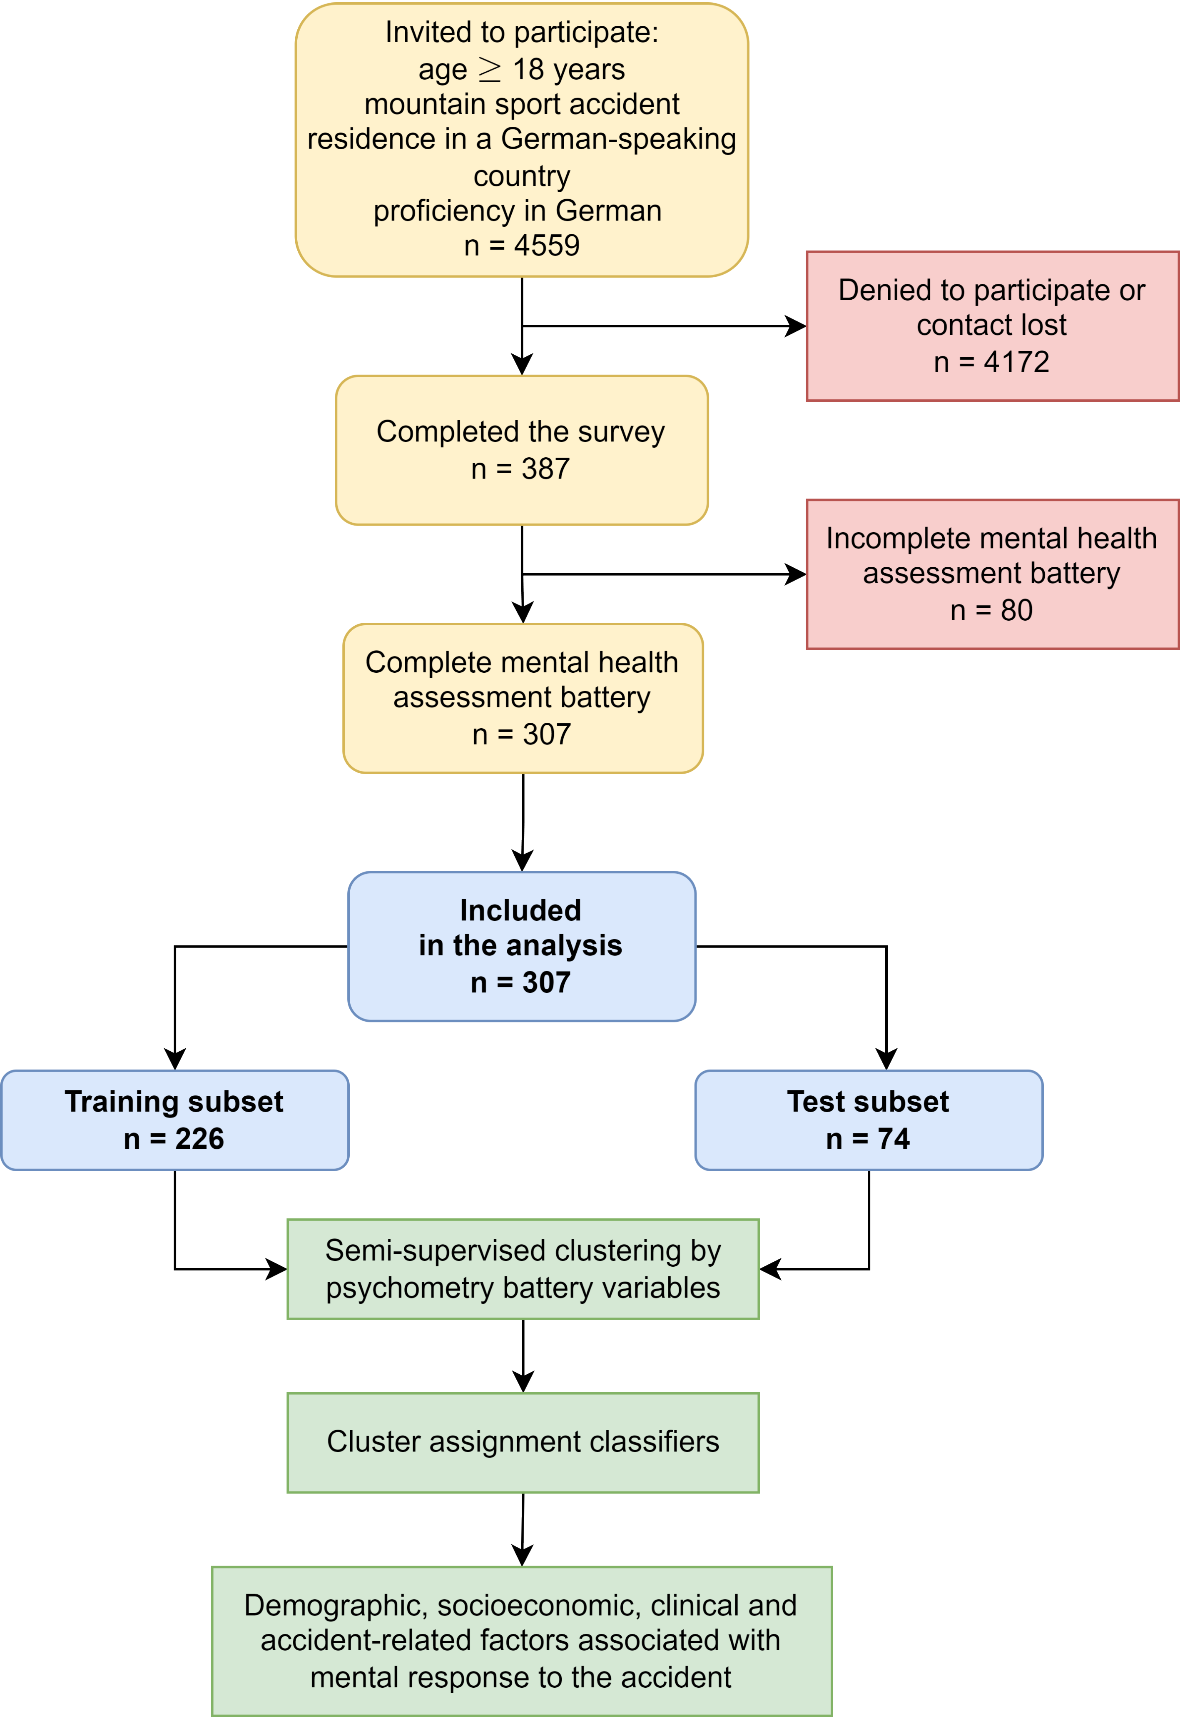

**Figure 1. Flow diagram of the analysis inclusion process.**

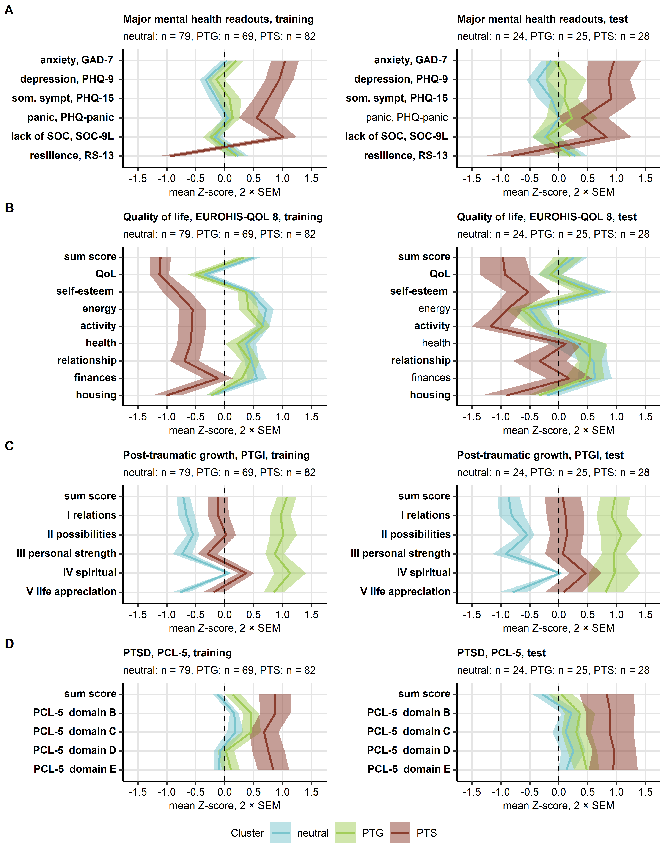

**Figure 2. Scores of symptoms of mental disorder, sense of coherence, resilience, quality of life, post-traumatic growth, and post-traumatic stress disorder in the mental health clusters.**

*Study participants in the training subset of the cohort were assigned to the neutral, PTG (post-traumatic growth) and PTS (post-traumatic stress) mental health clusters defined in respect to psychometric scores by the partition around medoids (PAM) algorithm. Study participants in the test subset of the cohort were assigned to the mental health clusters by the inverse distance weighted 7-nearest neighbors’ classifier. Differences in the cluster-defining psychometric scores between the clusters were assessed by Kruskal-Wallis test with effect size statistic. P values were adjusted for multiple testing with the false discovery rate method. Mean normalized scores of major mental health readouts, sense of coherence and resilience (A), quality of life (B), post-traumatic growth (C) and post-traumatic stress disorder (PTSD, D) in the mental health clusters of the training and test subsets of the study cohort are depicted as solid lines. Tinted regions represent 2 SEM (standard error of the mean). Numbers of observations in the clusters are displayed in the plot captions. Significant effects are highlighted in bold.* *GAD-7: 7-item general anxiety disorder scale; PHQ-9: patient health questionnaire 9 item scale for depressive symptoms; PHQ-15: patient health questionnaire 15 item scale assessing common somatic symptoms as a substitute for somatization; som. sympt.: somatic symptoms; EUROHIS-QOL 8: 8-item EUROHIS project quality of life scale; SOC-9L: Leipzig 9-item sense of coherence questionnaire; RS13: 13-item resilience scale; PCL-5: PTSD checklist for DSM-5; PTGI: post-traumatic growth inventory; PTSD: post-traumatic stress disorder.*

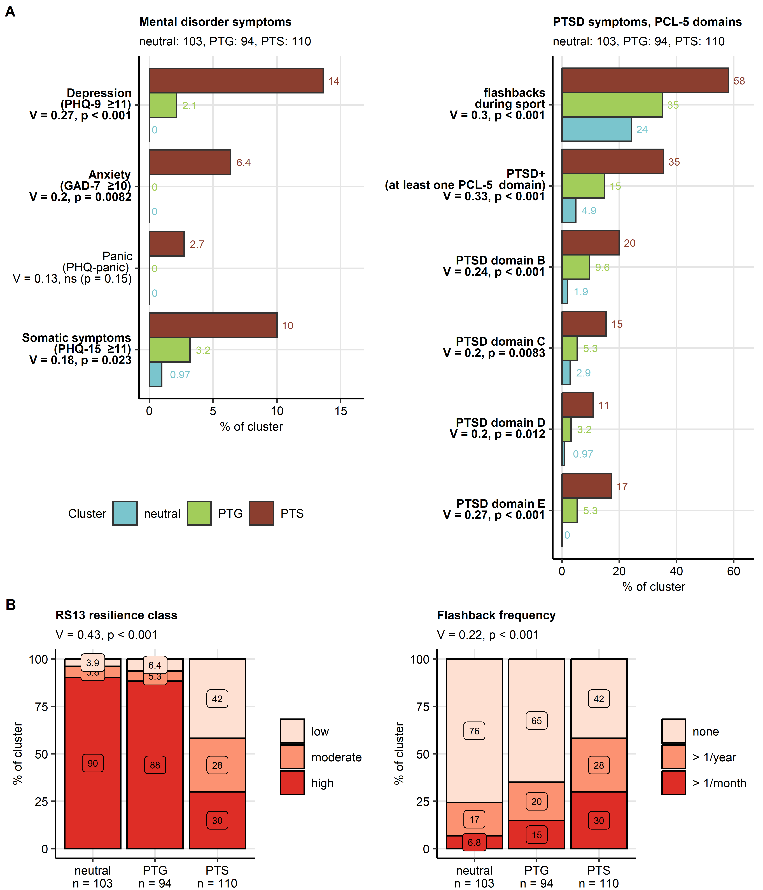

**Figure 3. Symptoms of mental disorders and resilience classes in the mental health clusters.**

*Differences in frequency of symptoms of mental disorders and flashbacks, and distribution of resilience classes between the mental health clusters (neutral, post-traumatic growth [PTG] and post-traumatic stress [PTS]) were investigated in the entire study cohort by test with Cramer’s V effect size statistic. P values were adjusted for multiple testing with the false discovery rate method.*

*(A) Symptoms of mental disorders, presence of flashbacks during mountain sport activity and symptoms of post-traumatic stress disorder (PTSD). Percentages of affected individuals in the mental health clusters are presented in bar plots. Effect sizes and p values are indicated in the Y axes. Significant effects are highlighted in bold. Numbers of observations in the clusters are indicated in the plot captions.*

*(B) Resilience classes and frequency of flashbacks during mountain sport activity in the mental health clusters presented in stack plots. Effect sizes and p values are displayed in the plot captions. Numbers of observations in the clusters are indicated in the X axes.*

*GAD-7: 7-item general anxiety disorder scale; PHQ-9: patient health questionnaire 9 item scale for depressive symptoms; PHQ-15: patient health questionnaire 15 item scale assessing common somatic symptoms as a substitute for somatization; RS13: 13-item resilience scale; PCL-5: PTSD checklist for DSM-5; PTSD: post-traumatic stress disorder.*

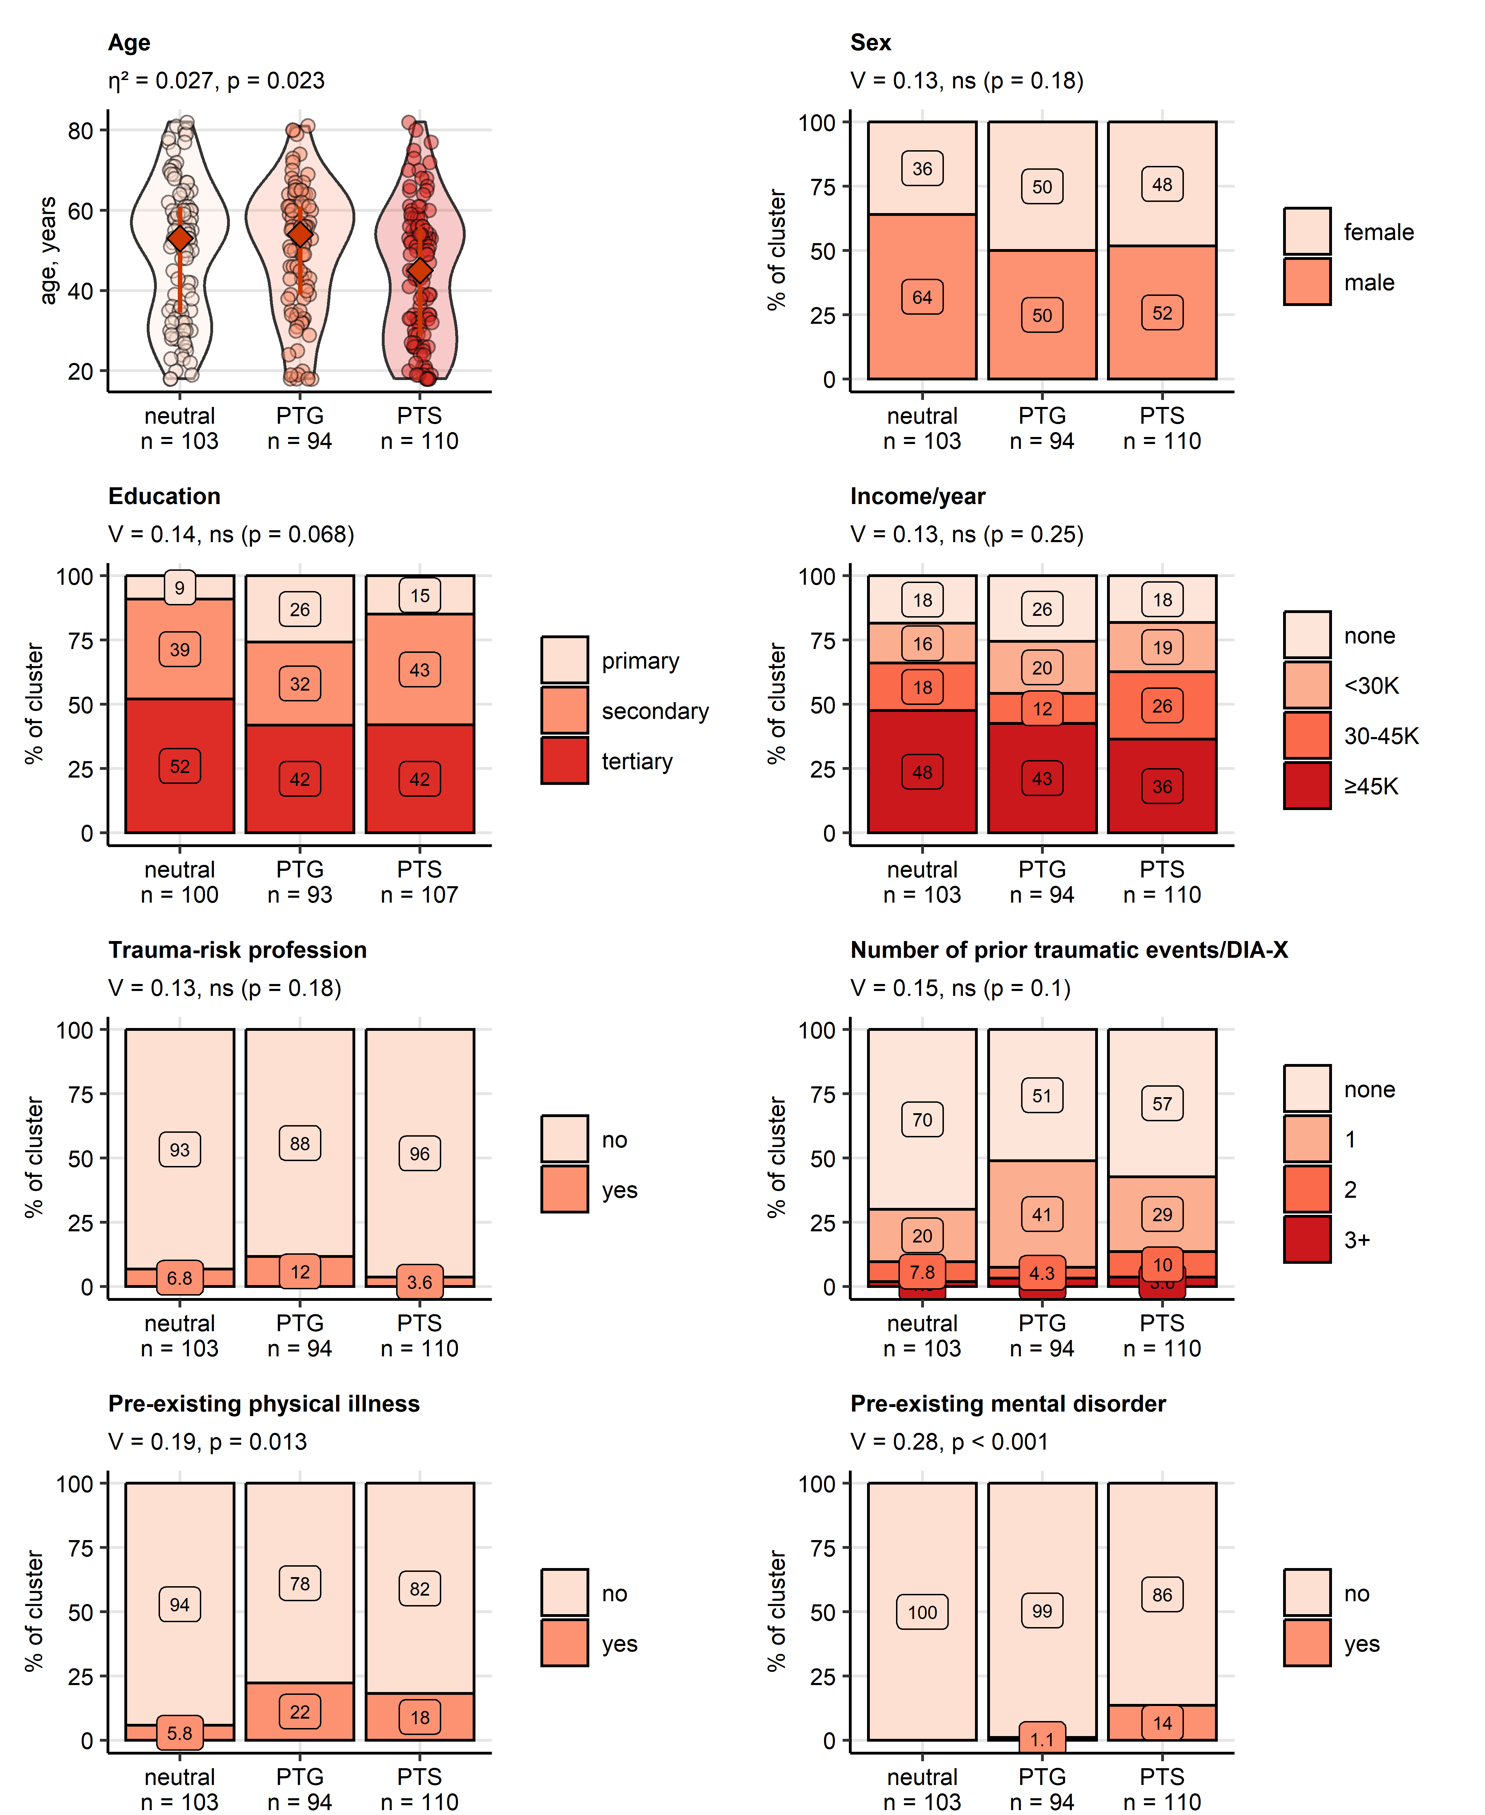

**Figure 4. Sociodemographic and medical history characteristic of the mental health clusters.**

*Differences in age at the time of the accident between the mental health clusters (neutral, post-traumatic growth [PTG], post-traumatic stress [PTS]) were assessed in the entire cohort by Kruskal-Wallis test with effect size statistic. Differences in genders, education, annual income classes (K: 1000 Euro), percentages of participants with a search and rescue profession, traumatic events in the past (DIA-X: Diagnostic Expert System, traumatic event score), as well as pre-existing physical illness and pre-existing professionally diagnosed mental disorders between the mental health clusters were investigated in the entire cohort by test with Cramer’s V effect size statistic. P values were adjusted for multiple testing with the false discovery rate method. Age is presented in violin plots with single observations visualized as points and medians with interquartile ranges depicted by red diamonds and whiskers. The remaining variables are presented as percentages of the clusters in stack plots. Effect sizes and p values are displayed in the plot captions. Numbers of observations in the clusters are indicated in the X axes.*

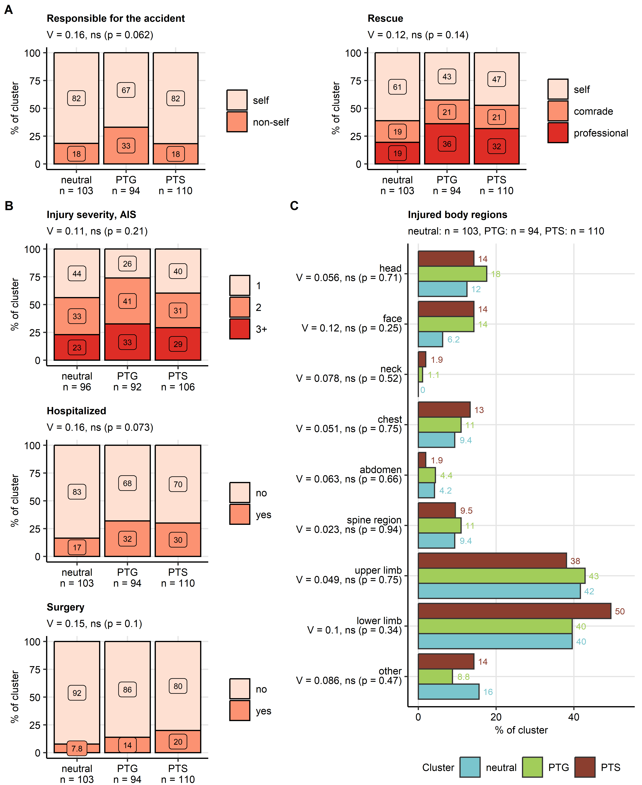

**Figure 5. Responsibility for the accident, accident rescue, injury severity and injured body parts in the mental health clusters.**

*Differences in responsibility for the accident, rescue mode, injury severity, hospitalization and surgery rates, and injured body regions between the mental clusters (neutral, post-traumatic growth [PTG], post-traumatic stress [PTS]) were investigated in the entire cohort by test with Cramer’s V effect size statistic. P values were adjusted for multiple testing with the false discovery rate method.*

*(A, B) Percentages of self and non-self accident culprit, distribution of the rescue modes and injury severity classes (AIS: abbreviated injury scale), rates of hospitalization and surgery in the mental clusters were presented in stack plots. Effect sizes and p values are displayed in the plot captions. Numbers of observations in the clusters are indicated in the X axes.*

*(C) Percentages of injured body regions were presented in a bar plot. Effect sizes and p values are indicated in the Y axis. Numbers of observations in the clusters are displayed in the plot captions.*

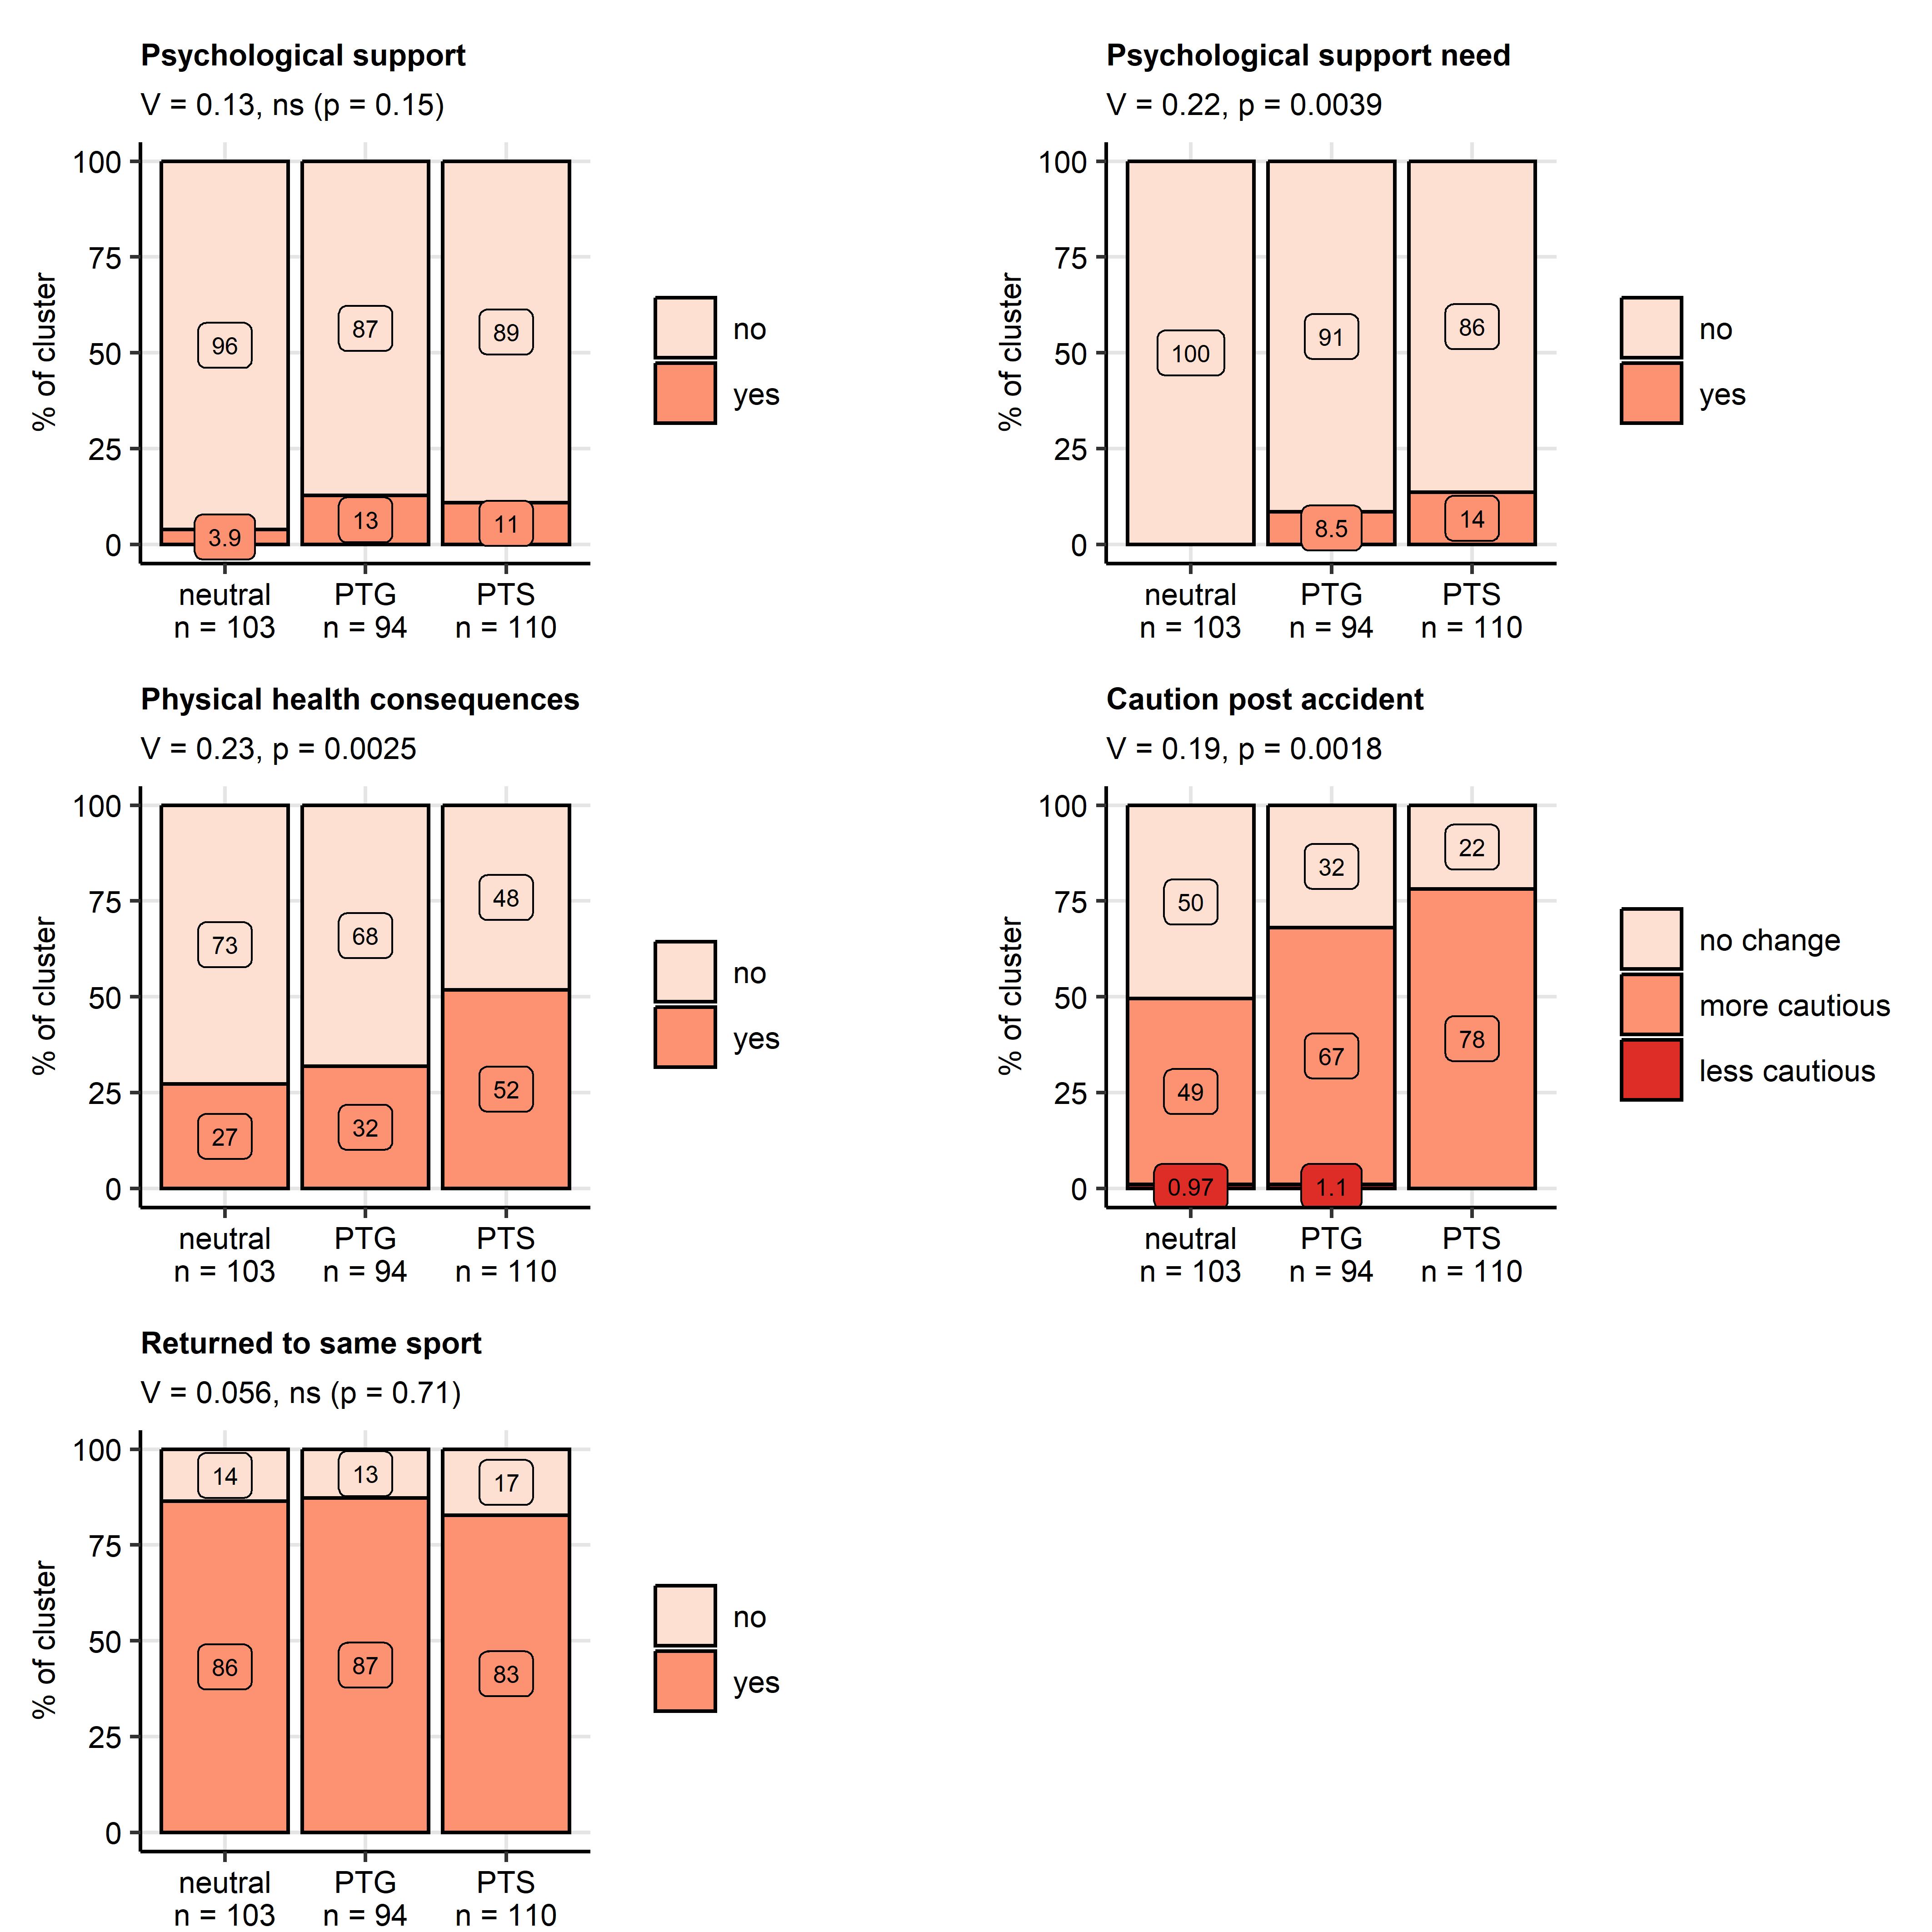

**Figure 6. Psychological support and consequences of the accident in the mental health clusters.**

*Differences in rates of received psychological or psychiatric support, self-reported need for psychological or psychiatric support at the time of the accidentsupport, persistent physical health consequences of the accident, cautious behavior during mountain sport and percentages of participants having returned to the same mountain sport between the mental health clusters (neutral, post-traumatic growth [PTG], post-traumatic stress [PTS]) were assessed in the entire cohort by test with Cramer V effect size statistic. P values were adjusted for multiple testing with the false discovery rate method. Percentages within the clusters are presented in stack plots. Effect sizes and p values are displayed in the plot captions. Numbers of observations in the clusters are indicated in the X axes.*

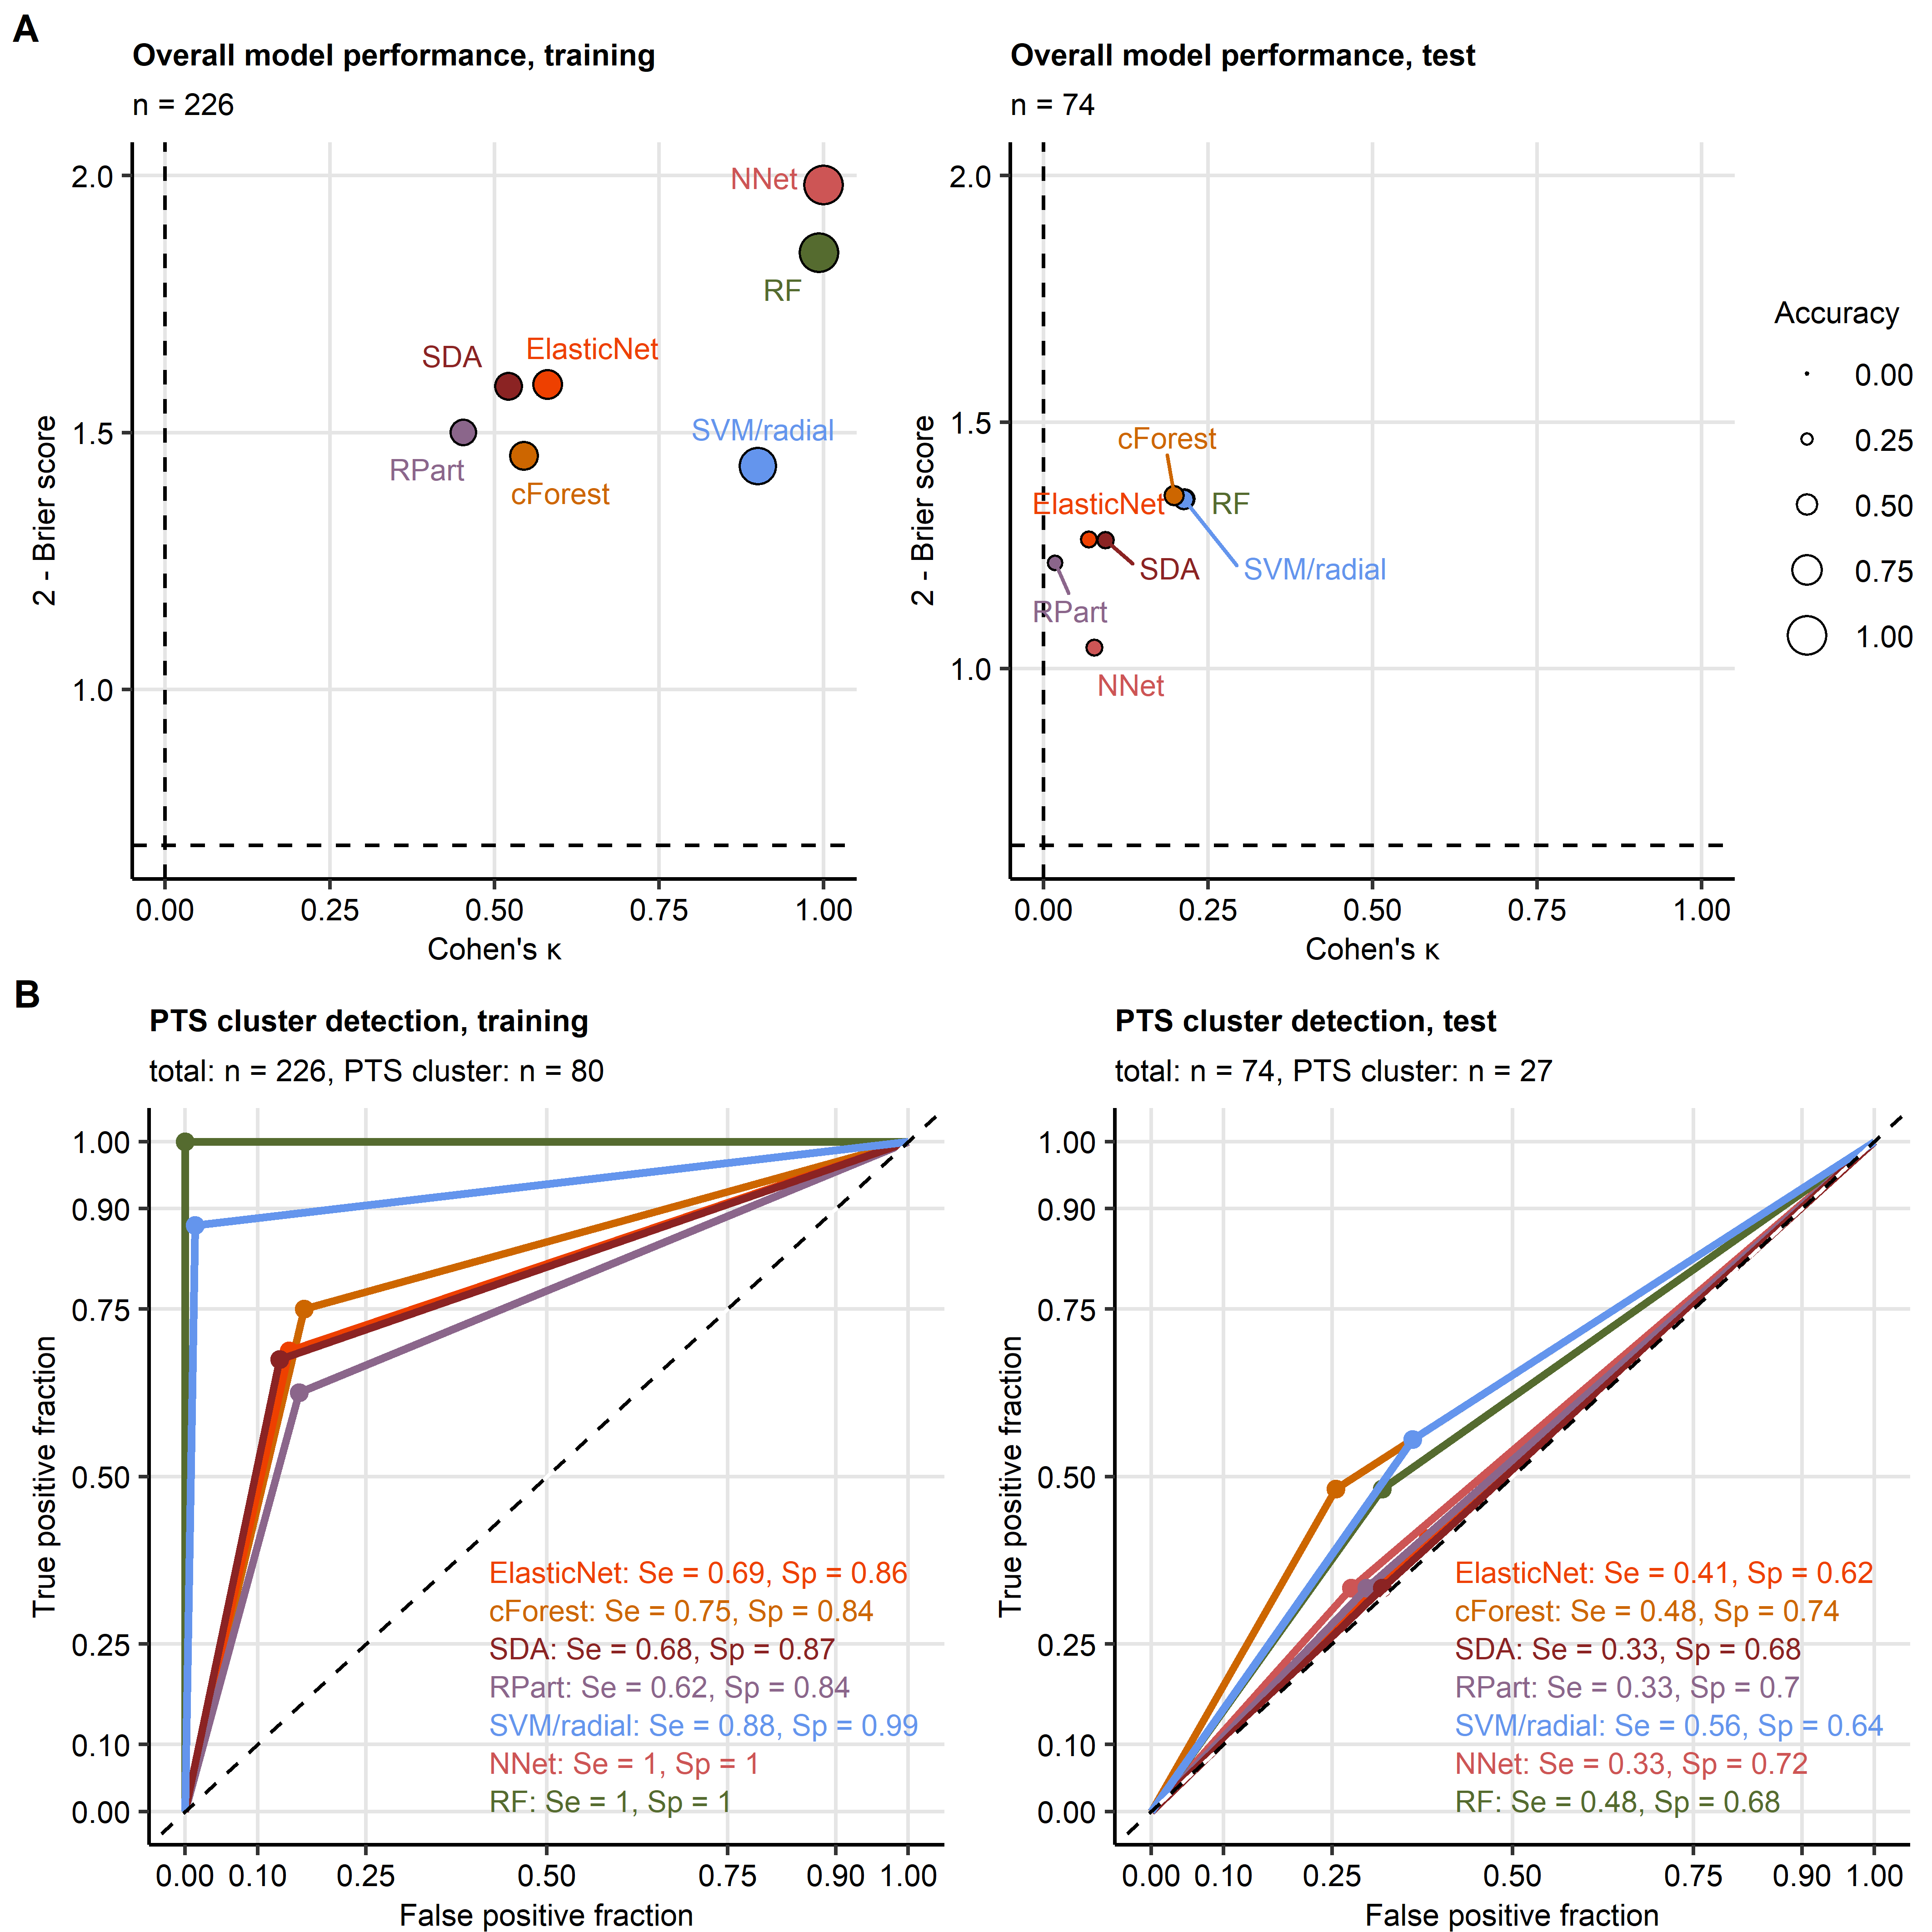

**Figure 7. Assignment of accident victims to the mental health clusters based on explanatory factors available during acute medical management of the accident.**

*The mental health cluster assignment was modeled with demographic, medical history and accident-related explanatory factors available during acute medical management of the accident. Psychometric variables obtained at time of survey (i.e. not during the acute medical management) used for cluster definition such as symptoms of mental disorders, resilience classes as well as presence and frequency of flashbacks were excluded from the explanatory factor set.*

*(A) Accuracy of the predicted Cluster assignment and predictive performance of the modeling algorithms was assessed by overall cluster assignment accuracy, Cohen’s inter-rater accuracy metric (high values indicate good accuracy) and Brier score (low values indicate good performance) in the training and test subsets of the study cohort. Performance metrics are presented in scatter plots. Point size codes for the overall cluster assignment accuracy. Point color codes for the modeling algorithm. Numbers of complete observations are displayed in the plot captions.*

*(B) Sensitivity (Se) and specificity (Sp) of detection of participants assigned to the PTS cluster (post-traumatic stress) investigated by receiver-operating characteristic in the training and test subset of the study cohort. Sensitivity and specificity values are indicated in the plots. Line color codes for the modeling algorithm. Numbers of complete observations and observations in the PTS cluster are indicated in the plot captions.*

*RF: random forest; NNet: neural network with a single hidden layer; SVM/radial: support vector machines with radial kernel; RPart: recursive partitioning; SDA: shrinkage discriminant analysis; cForest: conditional random forest; Elastic Net: elastic net multinomial regression.*

# References

1. Hedenborg S, Fredman P, Hansen AS, Wolf-Watz D. Outdoorification of sports and recreation: a leisure transformation under the COVID-19 pandemic in Sweden. *https://doiorg/101080/1174539820222101497* (2022) doi: [10.1080/11745398.2022.2101497](https://doi.org/10.1080/11745398.2022.2101497)

2. Ower C, Kemmler G, Vill T, Martini C, Schmitt A, Sperner-Unterweger B, Hüfner K. The effect of physical activity in an alpine environment on quality of life is mediated by resilience in patients with psychosomatic disorders and healthy controls. *European Archives of Psychiatry and Clinical Neuroscience* (2019) 269:543. doi: [10.1007/S00406-018-0930-2](https://doi.org/10.1007/S00406-018-0930-2)

3. Niedermeier M, Hartl A, Kopp M. Prevalence of Mental Health Problems and Factors Associated with Psychological Distress in Mountain Exercisers: A Cross-Sectional Study in Austria. *Frontiers in psychology* (2017) 8: doi: [10.3389/FPSYG.2017.01237](https://doi.org/10.3389/FPSYG.2017.01237)

4. Niedermeier M, Einwanger J, Hartl A, Kopp M. Affective responses in mountain hiking-A randomized crossover trial focusing on differences between indoor and outdoor activity. *PloS one* (2017) 12: doi: [10.1371/JOURNAL.PONE.0177719](https://doi.org/10.1371/JOURNAL.PONE.0177719)

5. Faulhaber M, Pocecco E, Niedermeier M, Ruedl G, Walter D, Sterr R, Ebner H, Schobersberger W, Burtscher M. Fall-related accidents among hikers in the Austrian Alps: a 9-year retrospective study. *BMJ Open Sport — Exercise Medicine* (2017) 3: doi: [10.1136/BMJSEM-2017-000304](https://doi.org/10.1136/BMJSEM-2017-000304)

6. Faulhaber M, Pocecco E, Posch M, Ruedl G. Accidents during mountain hiking and alpine skiing – epidemiological data from the Austrian alps. *Deutsche Zeitschrift fur Sportmedizin* (2020) 71:293–299. doi: [10.5960/DZSM.2020.465](https://doi.org/10.5960/DZSM.2020.465)

7. Bryant RA. Post-traumatic stress disorder: a state-of-the-art review of evidence and challenges. *World psychiatry: official journal of the World Psychiatric Association (WPA)* (2019) 18:259–269. doi: [10.1002/WPS.20656](https://doi.org/10.1002/WPS.20656)

8. American Psychiatric Association. *Diagnostic and Statistical Manual of Mental Disorders*. American Psychiatric Association (2013). doi: [10.1176/appi.books.9780890425596](https://doi.org/10.1176/appi.books.9780890425596)

9. Howie H, Rijal CM, Ressler KJ. A review of epigenetic contributions to post-traumatic stress disorder. *Dialogues in clinical neuroscience* (2019) 21:417–428. doi: [10.31887/DCNS.2019.21.4/KRESSLER](https://doi.org/10.31887/DCNS.2019.21.4/KRESSLER)

10. Gagnon-Sanschagrin P, Schein J, Urganus A, Serra E, Liang Y, Musingarimi P, Cloutier M, Guérin A, Davis LL. Identifying individuals with undiagnosed post-traumatic stress disorder in a large United States civilian population – a machine learning approach. *BMC Psychiatry* (2022) 22:1–11. doi: [10.1186/S12888-022-04267-6/TABLES/2](https://doi.org/10.1186/S12888-022-04267-6/TABLES/2)

11. Brady KT, Killeen TK, Lucerini S. Comorbidity of Psychiatric Disorders and Posttraumatic Stress Disorder. *The Primary Care Companion for CNS Disorders* (2000) 2:3403. <https://www.psychiatrist.com/pcc/trauma/ptsd/comorbidity-psychiatric-disorders-posttraumatic-stress https://www.psychiatrist.com/jcp/medical/comorbidity/comorbidity-psychiatric-disorders-posttraumatic-stress-2/>

12. Benjet C, Bromet E, Karam EG, Kessler RC, McLaughlin KA, Ruscio AM, Shahly V, Stein DJ, Petukhova M, Hill E, et al. The epidemiology of traumatic event exposure worldwide: results from the World Mental Health Survey Consortium. *Psychological medicine* (2016) 46:327–343. doi: [10.1017/S0033291715001981](https://doi.org/10.1017/S0033291715001981)

13. Breslau N, Wilcox HC, Storr CL, Lucia VC, Anthony JC. Trauma exposure and posttraumatic stress disorder: a study of youths in urban America. *Journal of urban health : bulletin of the New York Academy of Medicine* (2004) 81:530–544. doi: [10.1093/JURBAN/JTH138](https://doi.org/10.1093/JURBAN/JTH138)

14. Trautmann S, Wittchen H-U. Trauma and PTSD in Europe. *Case Studies in Clinical Psychological Science: Bridging the Gap from Science to Practice* (2018)1–7. doi: [10.1093/MED/9780190259440.003.0008](https://doi.org/10.1093/MED/9780190259440.003.0008)

15. Burri A, Maercker A. Differences in prevalence rates of PTSD in various European countries explained by war exposure, other trauma and cultural value orientation. *BMC research notes* (2014) 7: doi: [10.1186/1756-0500-7-407](https://doi.org/10.1186/1756-0500-7-407)

16. Joseph NM, Benedick A, Flanagan CD, Breslin MA, Simpson M, Ragone C, Kalina M, Hendrickson SB, Vallier HA. Prevalence of posttraumatic stress disorder in acute trauma patients. *OTA international : the open access journal of orthopaedic trauma* (2020) 3:e056. doi: [10.1097/OI9.0000000000000056](https://doi.org/10.1097/OI9.0000000000000056)

17. Ziobrowski HN, Kennedy CJ, Ustun B, House SL, Beaudoin FL, An X, Zeng D, Bollen KA, Petukhova M, Sampson NA, et al. Development and Validation of a Model to Predict Posttraumatic Stress Disorder and Major Depression After a Motor Vehicle Collision. *JAMA Psychiatry* (2021) 78:1228–1237. doi: [10.1001/JAMAPSYCHIATRY.2021.2427](https://doi.org/10.1001/JAMAPSYCHIATRY.2021.2427)

18. Papini S, Pisner D, Shumake J, Powers MB, Beevers CG, Rainey EE, Smits JAJ, Warren AM. Ensemble machine learning prediction of posttraumatic stress disorder screening status after emergency room hospitalization. *Journal of anxiety disorders* (2018) 60:35–42. doi: [10.1016/J.JANXDIS.2018.10.004](https://doi.org/10.1016/J.JANXDIS.2018.10.004)

19. Schultebraucks K, Shalev AY, Michopoulos V, Grudzen CR, Shin SM, Stevens JS, Maples-Keller JL, Jovanovic T, Bonanno GA, Rothbaum BO, et al. A validated predictive algorithm of post-traumatic stress course following emergency department admission after a traumatic stressor. *Nature medicine* (2020) 26:1084–1088. doi: [10.1038/S41591-020-0951-Z](https://doi.org/10.1038/S41591-020-0951-Z)

20. Wafa MH, Viprey M, Magaud L, Haesebaert J, Leaune E, Poulet E, Bied C, Schott AM. Identification of biopSychoSocial factors predictive of post-traUmatic stress disorder in patients admitted to the Emergency department after a trauma (ISSUE): protocol for a multicenter prospective study. *BMC psychiatry* (2019) 19: doi: [10.1186/S12888-019-2154-Z](https://doi.org/10.1186/S12888-019-2154-Z)

21. Shalev AY, Gevonden M, Ratanatharathorn A, Laska E, Mei WF van der, Qi W, Lowe S, Lai BS, Bryant RA, Delahanty D, et al. Estimating the risk of PTSD in recent trauma survivors: results of the International Consortium to Predict PTSD (ICPP). *World psychiatry : official journal of the World Psychiatric Association (WPA)* (2019) 18:77–87. doi: [10.1002/WPS.20608](https://doi.org/10.1002/WPS.20608)

22. Linares IMP, Corchs FDF, Chagas MHN, Zuardi AW, Martın-Santos R, Crippa JAS. Early interventions for the prevention of PTSD in adults: a systematic literature review. *Archives of Clinical Psychiatry (São Paulo)* (2017) 44:23–29. doi: [10.1590/0101-60830000000109](https://doi.org/10.1590/0101-60830000000109)

23. Qi W, Gevonden M, Shalev A. Prevention of Post-Traumatic Stress Disorder After Trauma: Current Evidence and Future Directions. *Current psychiatry reports* (2016) 18:1–11. doi: [10.1007/S11920-015-0655-0](https://doi.org/10.1007/S11920-015-0655-0)

24. Tedeschi RG, Calhoun LG. The Posttraumatic Growth Inventory: measuring the positive legacy of trauma. *Journal of traumatic stress* (1996) 9:455–471. doi: [10.1007/BF02103658](https://doi.org/10.1007/BF02103658)

25. Ahmed AS. Post-traumatic stress disorder, resilience and vulnerability. *Advances in Psychiatric Treatment* (2007) 13:369–375. doi: [10.1192/APT.BP.106.003236](https://doi.org/10.1192/APT.BP.106.003236)

26. Bensimon M. Elaboration on the association between trauma, PTSD and posttraumatic growth: The role of trait resilience. *Personality and Individual Differences* (2012) 52:782–787. doi: [10.1016/J.PAID.2012.01.011](https://doi.org/10.1016/J.PAID.2012.01.011)

27. Léonard C, Charriau-Perret A, Debaty G, Belle L, Ricard C, Sanchez C, Dupré PM, Panoff G, Bougerol T, Viglino D, et al. Survivors of avalanche accidents: posttraumatic stress disorder symptoms and quality of life: a multicentre study. *Scandinavian Journal of Trauma, Resuscitation and Emergency Medicine* (2021) 29:1–11. doi: [10.1186/S13049-021-00912-3/FIGURES/2](https://doi.org/10.1186/S13049-021-00912-3/FIGURES/2)

28. Sommer I, Ehlert U. Adjustment to trauma exposure: Prevalence and predictors of posttraumatic stress disorder symptoms in mountain guides. *Journal of Psychosomatic Research* (2004) 57:329–335. doi: [10.1016/j.jpsychores.2004.01.010](https://doi.org/10.1016/j.jpsychores.2004.01.010)

29. Mikutta C, Schmid JJ, Ehlert U. Resilience and Post-traumatic Stress Disorder in the Swiss Alpine Rescue Association. *Frontiers in psychiatry* (2022) 13: doi: [10.3389/FPSYT.2022.780498](https://doi.org/10.3389/FPSYT.2022.780498)

30. Thordardottir EB, Valdimarsdottir UA, Hansdottir I, Resnick H, Shipherd JC, Gudmundsdottir B. Posttraumatic stress and other health consequences of catastrophic avalanches: A 16-year follow-up of survivors. *Journal of anxiety disorders* (2015) 32:103–111. doi: [10.1016/J.JANXDIS.2015.03.005](https://doi.org/10.1016/J.JANXDIS.2015.03.005)

31. Traber D, Le Barbenchon E, Hot P, Pellissier S. Perspectives about the PTSD prevalence rate in the case of multiple traumatic events exposure among mountain workers. *European Journal of Trauma & Dissociation* (2020) 4:100109. doi: [10.1016/J.EJTD.2019.05.002](https://doi.org/10.1016/J.EJTD.2019.05.002)

32. Spitzer RL, Kroenke K, Williams JBW, Löwe B. A Brief Measure for Assessing Generalized Anxiety Disorder: The GAD-7. *Archives of Internal Medicine* (2006) 166:1092–1097. doi: [10.1001/ARCHINTE.166.10.1092](https://doi.org/10.1001/ARCHINTE.166.10.1092)

33. Löwe B, Spitzer RL, Zipfel S, Herzog W. Auflage Manual 17.07. (2002).

34. Gräfe K, Zipfel S, Herzog W, Löwe B. Screening psychischer störungen mit dem "Gesundheitsfragebogen für Patienten (PHQ-D)". Ergebnisse der Deutschen validierungsstudie. *Diagnostica* (2004) 50:171–181. doi: [10.1026/0012-1924.50.4.171](https://doi.org/10.1026/0012-1924.50.4.171)

35. Kroenke K, Spitzer RL, Williams JBW. The PHQ-15: validity of a new measure for evaluating the severity of somatic symptoms. *Psychosomatic medicine* (2002) 64:258–266. doi: [10.1097/00006842-200203000-00008](https://doi.org/10.1097/00006842-200203000-00008)

36. Leppert K, Koch B, Brähler E, Und BS-KD, 2008 U. Die Resilienzskala (RS)–Überprüfung der Langform RS-25 und einer Kurzform RS-13. *Klinische Diagnostik und Evaluation* (2008) 1:226–243. <https://www.academia.edu/download/44388154/A_406.pdf>

37. Schumacher J, Wilz G, Gunzelmann T, Brähler E. Die sense of coherence scale von antonovsky: Teststatische überprüfung in einer repräsentativen bevölkerungsstichprobe und konstruktion einer kurzskala. *PPmP Psychotherapie Psychosomatik Medizinische Psychologie* (2000) 50:472–482. doi: [10.1055/s-2000-9207](https://doi.org/10.1055/s-2000-9207)

38. Schmidt S, Mühlan H, Power M. The EUROHIS-QOL 8-item index: psychometric results of a cross-cultural field study. *European Journal of Public Health* (2006) 16:420–428. doi: [10.1093/EURPUB/CKI155](https://doi.org/10.1093/EURPUB/CKI155)

39. Bovin MJ, Marx BP, Weathers FW, Gallagher MW, Rodriguez P, Schnurr PP, Keane TM. Psychometric properties of the PTSD Checklist for Diagnostic and Statistical Manual of Mental Disorders-Fifth Edition (PCL-5) in veterans. *Psychological assessment* (2016) 28:1379–1391. doi: [10.1037/PAS0000254](https://doi.org/10.1037/PAS0000254)

40. McDonald RP. *Test theory: A unified treatment*. 1st Editio. New Yor: Psychology Press (1999). doi: [10.4324/9781410601087](https://doi.org/10.4324/9781410601087)

41. Manea L, Gilbody S, McMillan D. Optimal cut-off score for diagnosing depression with the Patient Health Questionnaire (PHQ-9): A meta-analysis. *CMAJ* (2012) 184:E191. doi: [10.1503/CMAJ.110829/-/DC1](https://doi.org/10.1503/CMAJ.110829/-/DC1)

42. Maercker A, Bromberger F. Checklisten und Fragebogen zur Erfassung traumatischer Ereignisse in deutscher Sprache. *Trierer Psychologische Berichte* (2005) 32:

43. O’Brien CP. The CAGE Questionnaire for Detection of Alcoholism. *JAMA* (2008) 300:2054–2056. doi: [10.1001/JAMA.2008.570](https://doi.org/10.1001/JAMA.2008.570)

44. Gennarelli TA, Wodzin E. AIS 2005: A contemporary injury scale. *Injury* (2006) 37:1083–1091. doi: [10.1016/j.injury.2006.07.009](https://doi.org/10.1016/j.injury.2006.07.009)

45. Kassambara A, Mundt F. factoextra: Extract and Visualize the Results of Multivariate Data Analyses. (2020) <https://cran.r-project.org/web/packages/factoextra/index.html>

46. Kassambara A. rstatix: Pipe-Friendly Framework for Basic Statistical Tests. (2021) <https://cran.r-project.org/package=rstatix>

47. Drost H-G. Philentropy: Information Theory and Distance Quantification with R. *Journal of Open Source Software* (2018) 3:765. doi: [10.21105/joss.00765](https://doi.org/10.21105/joss.00765)

48. Schubert E, Rousseeuw PJ. Faster k-Medoids Clustering: Improving the PAM, CLARA, and CLARANS Algorithms. *Lecture notes in computer science (including subseries lecture notes in artificial intelligence and lecture notes in bioinformatics)*. Springer (2019). p. 171–187 doi: [10.1007/978-3-030-32047-8_16](https://doi.org/10.1007/978-3-030-32047-8_16)

49. Rousseeuw PJ. Silhouettes: A graphical aid to the interpretation and validation of cluster analysis. *Journal of Computational and Applied Mathematics* (1987) 20:53–65. doi: [10.1016/0377-0427(87)90125-7](https://doi.org/10.1016/0377-0427(87)90125-7)

50. Lange T, Roth V, Braun ML, Buhmann JM. Stability-based validation of clustering solutions. *Neural Computation* (2004) 16:1299–1323. doi: [10.1162/089976604773717621](https://doi.org/10.1162/089976604773717621)

51. Wright MN, Ziegler A. ranger: A Fast Implementation of Random Forests for High Dimensional Data in C++ and R. *Journal of Statistical Software* (2017) 77:1–17. doi: [10.18637/JSS.V077.I01](https://doi.org/10.18637/JSS.V077.I01)

52. Breiman L. Random forests. *Machine Learning* (2001) 45:5–32. doi: [10.1023/A:1010933404324](https://doi.org/10.1023/A:1010933404324)

53. Ripley BD. *Pattern recognition and neural networks*. Cambridge University Press (2014). doi: [10.1017/CBO9780511812651](https://doi.org/10.1017/CBO9780511812651)

54. Karatzoglou A, Hornik K, Smola A, Zeileis A. kernlab - An S4 Package for Kernel Methods in R. *Journal of Statistical Software* (2004) 11:1–20. doi: [10.18637/JSS.V011.I09](https://doi.org/10.18637/JSS.V011.I09)

55. Weston J, Watkins C. Multi-Class Support Vector Machines. (1998)

56. Therneau TM, Atkinson B, Ripley BD. rpart: Recursive Partitioning and Regression Trees. (2022) <https://cran.r-project.org/web/packages/rpart/index.html>

57. Breiman L, Friedman JH, Olshen RA, Stone CJ. Classification and regression trees. *Classification and Regression Trees* (2017)1–358. doi: [10.1201/9781315139470/CLASSIFICATION-REGRESSION-TREES-LEO-BREIMAN](https://doi.org/10.1201/9781315139470/CLASSIFICATION-REGRESSION-TREES-LEO-BREIMAN)

58. Zou H, Hastie T. Regularization and variable selection via the elastic net. *Journal of the Royal Statistical Society Series B: Statistical Methodology* (2005) 67:301–320. doi: [10.1111/j.1467-9868.2005.00503.x](https://doi.org/10.1111/j.1467-9868.2005.00503.x)

59. Friedman J, Hastie T, Tibshirani R. Regularization paths for generalized linear models via coordinate descent. *Journal of Statistical Software* (2010) 33:1–22. doi: [10.18637/jss.v033.i01](https://doi.org/10.18637/jss.v033.i01)

60. Hothorn T, Hornik K, Zeileis A. Unbiased recursive partitioning: A conditional inference framework. *Journal of Computational and Graphical Statistics* (2006) 15:651–674. doi: [10.1198/106186006X133933](https://doi.org/10.1198/106186006X133933)

61. Strobl C, Boulesteix AL, Zeileis A, Hothorn T. Bias in random forest variable importance measures: Illustrations, sources and a solution. *BMC Bioinformatics* (2007) 8:1–21. doi: [10.1186/1471-2105-8-25/FIGURES/11](https://doi.org/10.1186/1471-2105-8-25/FIGURES/11)

62. Hothorn T, Hornik K, Strobl C, Zeileis A. party: A Laboratory for Recursive Partytioning. (2022) <https://cran.r-project.org/web/packages/party/index.html>

63. Cohen J. A Coefficient of Agreement for Nominal Scales. *Educational and Psychological Measurement* (1960) 20:37–46. doi: [10.1177/001316446002000104](https://doi.org/10.1177/001316446002000104)

64. Brier GW. VERIFICATION OF FORECASTS EXPRESSED IN TERMS OF PROBABILITY. *Monthly Weather Review* (1950) 78:1–3. doi: [10.1175/1520-0493(1950)078<0001:vofeit>2.0.co;2](https://doi.org/10.1175/1520-0493(1950)078<0001:vofeit>2.0.co;2)

65. Kuhn M. Building predictive models in R using the caret package. *Journal of Statistical Software* (2008) 28:1–26. doi: [10.18637/jss.v028.i05](https://doi.org/10.18637/jss.v028.i05)

66. Ahdesmäki M, Strimmer K. Feature selection in omics prediction problems using cat scores and false nondiscovery rate control. *https://doiorg/101214/09-AOAS277* (2010) 4:503–519. doi: [10.1214/09-AOAS277](https://doi.org/10.1214/09-AOAS277)

67. Ahdesmaki M, Zuber V, Gibb S, Strimmer K. sda: Shrinkage Discriminant Analysis and CAT Score Variable Selection. (2022) <https://cran.r-project.org/web/packages/sda/index.html>

68. Frans O, Rimmö PA, Åber L, Fredrikson M. Trauma exposure and post-traumatic stress disorder in the general population. *Acta psychiatrica Scandinavica* (2005) 111:291–290. doi: [10.1111/J.1600-0447.2004.00463.X](https://doi.org/10.1111/J.1600-0447.2004.00463.X)

69. PTSD. How Common is PTSD in Adults? - PTSD: National Center for PTSD. (2023) [https://www.ptsd.va.gov/understand/common/common_adults.asp#:$\sim$:text=About 6 out of every,criteria for PTSD after treatment](https://www.ptsd.va.gov/understand/common/common_adults.asp" \l ":$sim$:text=About 6 out of every,criteria for PTSD after treatment) [Accessed August 24, 2023]

70. Berger W, Coutinho ESF, Figueira I, Marques-Portella C, Luz MP, Neylan TC, Marmar CR, Mendlowicz MV. Rescuers at risk: a systematic review and meta-regression analysis of the worldwide current prevalence and correlates of PTSD in rescue workers. *Social psychiatry and psychiatric epidemiology* (2012) 47:1001–1011. doi: [10.1007/S00127-011-0408-2](https://doi.org/10.1007/S00127-011-0408-2)

71. Humer E, Schaffler Y, Jesser A, Probst T, Pieh C. Mental health in the Austrian general population during COVID-19: Cross-sectional study on the association with sociodemographic factors. *Frontiers in Psychiatry* (2022) 13: doi: [10.3389/FPSYT.2022.943303/FULL](https://doi.org/10.3389/FPSYT.2022.943303/FULL)

72. Liu AN, Wang LL, Li HP, Gong J, Liu XH. Correlation Between Posttraumatic Growth and Posttraumatic Stress Disorder Symptoms Based on Pearson Correlation Coefficient: A Meta-Analysis. *The Journal of nervous and mental disease* (2017) 205:380–389. doi: [10.1097/NMD.0000000000000605](https://doi.org/10.1097/NMD.0000000000000605)

73. Christiansen DM, Berke ET. Gender- and Sex-Based Contributors to Sex Differences in PTSD. *Current Psychiatry Reports* (2020) 22:1–9. doi: [10.1007/S11920-020-1140-Y/METRICS](https://doi.org/10.1007/S11920-020-1140-Y/METRICS)

74. Seedat S, Stein DJ, Carey PD. Post-traumatic stress disorder in women: epidemiological and treatment issues. *CNS drugs* (2005) 19:411–427. doi: [10.2165/00023210-200519050-00004](https://doi.org/10.2165/00023210-200519050-00004)

75. Baecher K, Kangas M, Taylor A, O’Donnell ML, Bryant RA, Silove D, McFarlane AC, Wade D. The role of site and severity of injury as predictors of mental health outcomes following traumatic injury. *Stress and health : journal of the International Society for the Investigation of Stress* (2018) 34:545–551. doi: [10.1002/SMI.2815](https://doi.org/10.1002/SMI.2815)

76. Kongshøj ILL, Berntsen D. Is Young Age a Risk Factor for PTSD? Age Differences in PTSD-Symptoms After Hurricane Florence. *Traumatology* (2022) doi: [10.1037/TRM0000389](https://doi.org/10.1037/TRM0000389)

77. Carbone JT, Holzer KJ, Vaughn MG. Posttraumatic Stress Disorder Among Low-Income Adolescents Experiencing Family-Neighborhood Income Disparities. *Journal of traumatic stress* (2019) 32:899–907. doi: [10.1002/JTS.22452](https://doi.org/10.1002/JTS.22452)

78. Sandweiss DA, Slymen DJ, LeardMann CA, Smith B, White MR, Boyko EJ, Hooper TI, Gackstetter GD, Amoroso PJ, Smith TC. Preinjury psychiatric status, injury severity, and postdeployment posttraumatic stress disorder. *Archives of general psychiatry* (2011) 68:496–504. doi: [10.1001/ARCHGENPSYCHIATRY.2011.44](https://doi.org/10.1001/ARCHGENPSYCHIATRY.2011.44)

79. Galatzer-Levy IR, Karstoft KI, Statnikov A, Shalev AY. Quantitative Forecasting of PTSD from Early Trauma Responses: A Machine Learning Application. *Journal of psychiatric research* (2014) 59:68. doi: [10.1016/J.JPSYCHIRES.2014.08.017](https://doi.org/10.1016/J.JPSYCHIRES.2014.08.017)

80. Cohen J. Statistical Power Analysis for the Behavioral Sciences. *Statistical Power Analysis for the Behavioral Sciences* (2013) doi: [10.4324/9780203771587](https://doi.org/10.4324/9780203771587)

81. Rice ME, Harris GT. Comparing effect sizes in follow-up studies: ROC area, Cohen’s d, and r. *Law and Human Behavior* (2005) 29:615–620. doi: [10.1007/S10979-005-6832-7](https://doi.org/10.1007/S10979-005-6832-7)

82. Blanchard EB, Hickling EJ, Mitnick N, Taylor AE, Loos WR, Buckley TC. The impact of severity of physical injury and perception of life threat in the development of post-traumatic stress disorder in motor vehicle accident victims. *Behaviour Research and Therapy* (1995) 33:529–534. doi: [10.1016/0005-7967(94)00079-Y](https://doi.org/10.1016/0005-7967(94)00079-Y)

83. Gabert-Quillen CA, Fallon W, Delahanty DL. PTSD after Traumatic Injury: An Investigation of the Impact of Injury Severity and Peritraumatic Moderators. *https://doiorg/101177/1359105310386823* (2011) 16:678–687. doi: [10.1177/1359105310386823](https://doi.org/10.1177/1359105310386823)